**MUBERWA AMANI NABELLA  
29376  
Database Management system**

**Assignment SQL Function**

**PART 1:String Function Q(15)**

1. SELECT CONCAT(first_name, ' ', last_name) AS full_name FROM employees; **29376**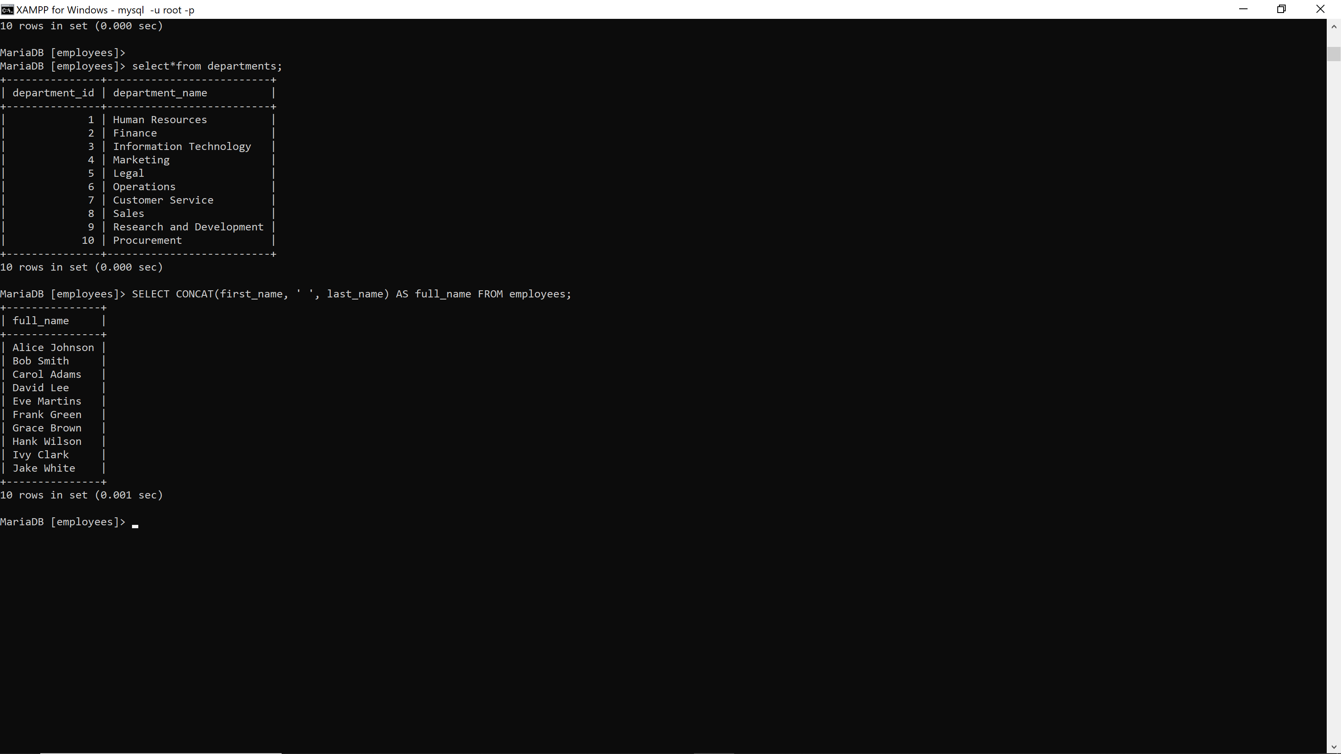
2. SELECT LOWER(first_name), LOWER(last_name) FROM employees; **29376**

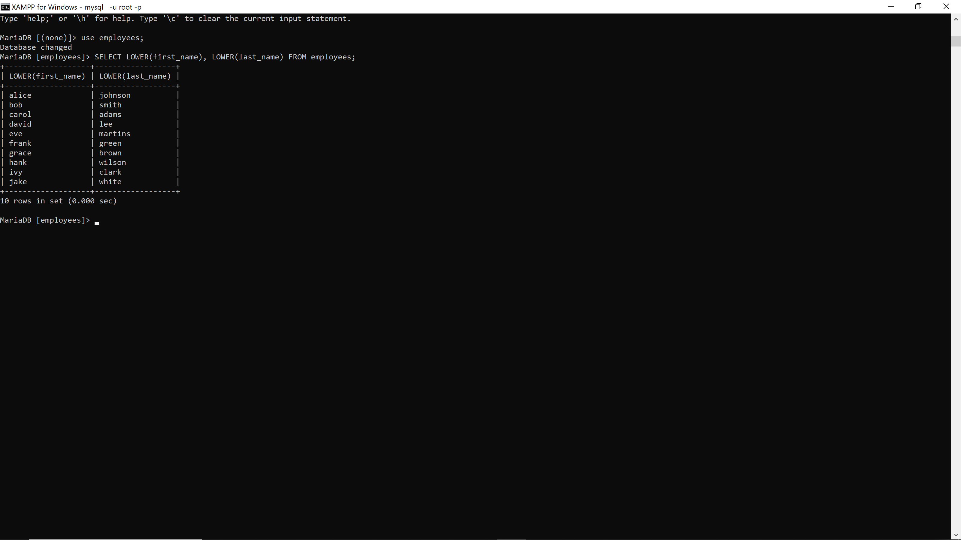

1. SELECT SUBSTRING(first_name, 1, 3) AS short_name FROM employees; **29376**
2. SELECT REPLACE(email, '@company.com', '@org.com') FROM employees; **29376**

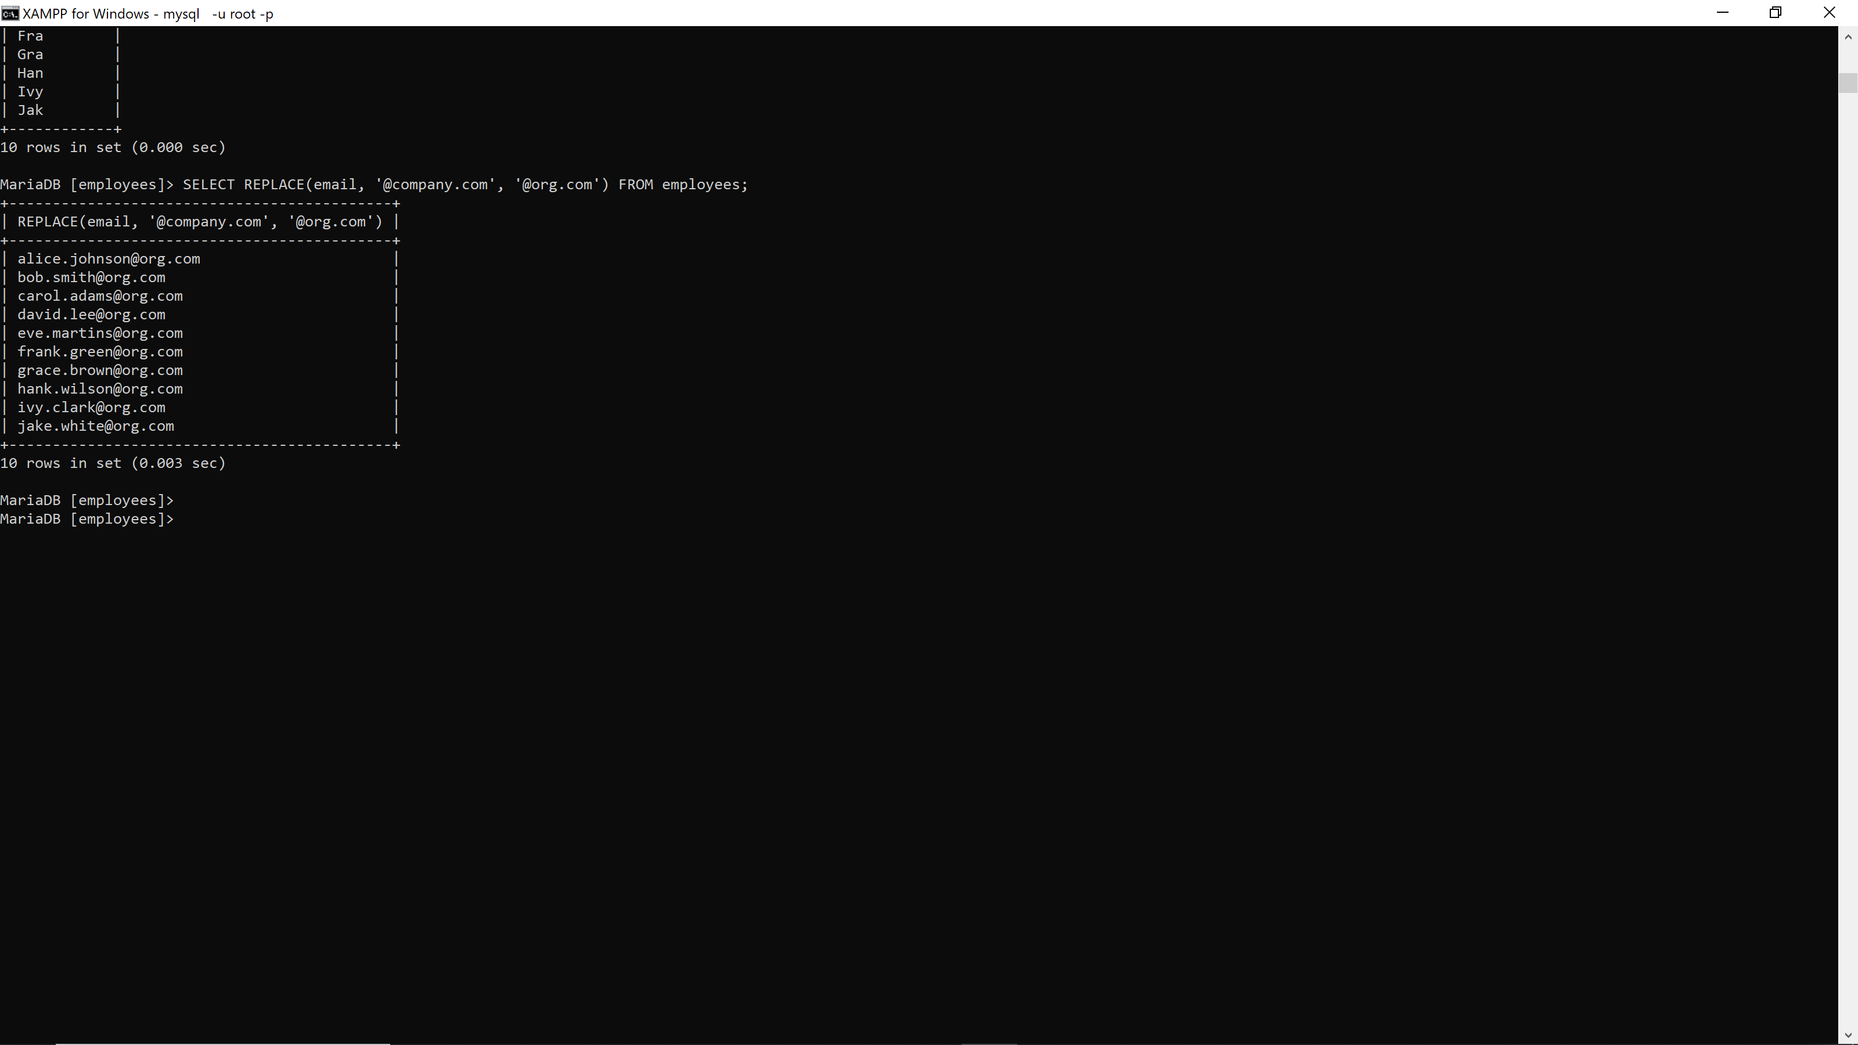

5. SELECT TRIM(' some string ') AS trimmed_string; **29376**

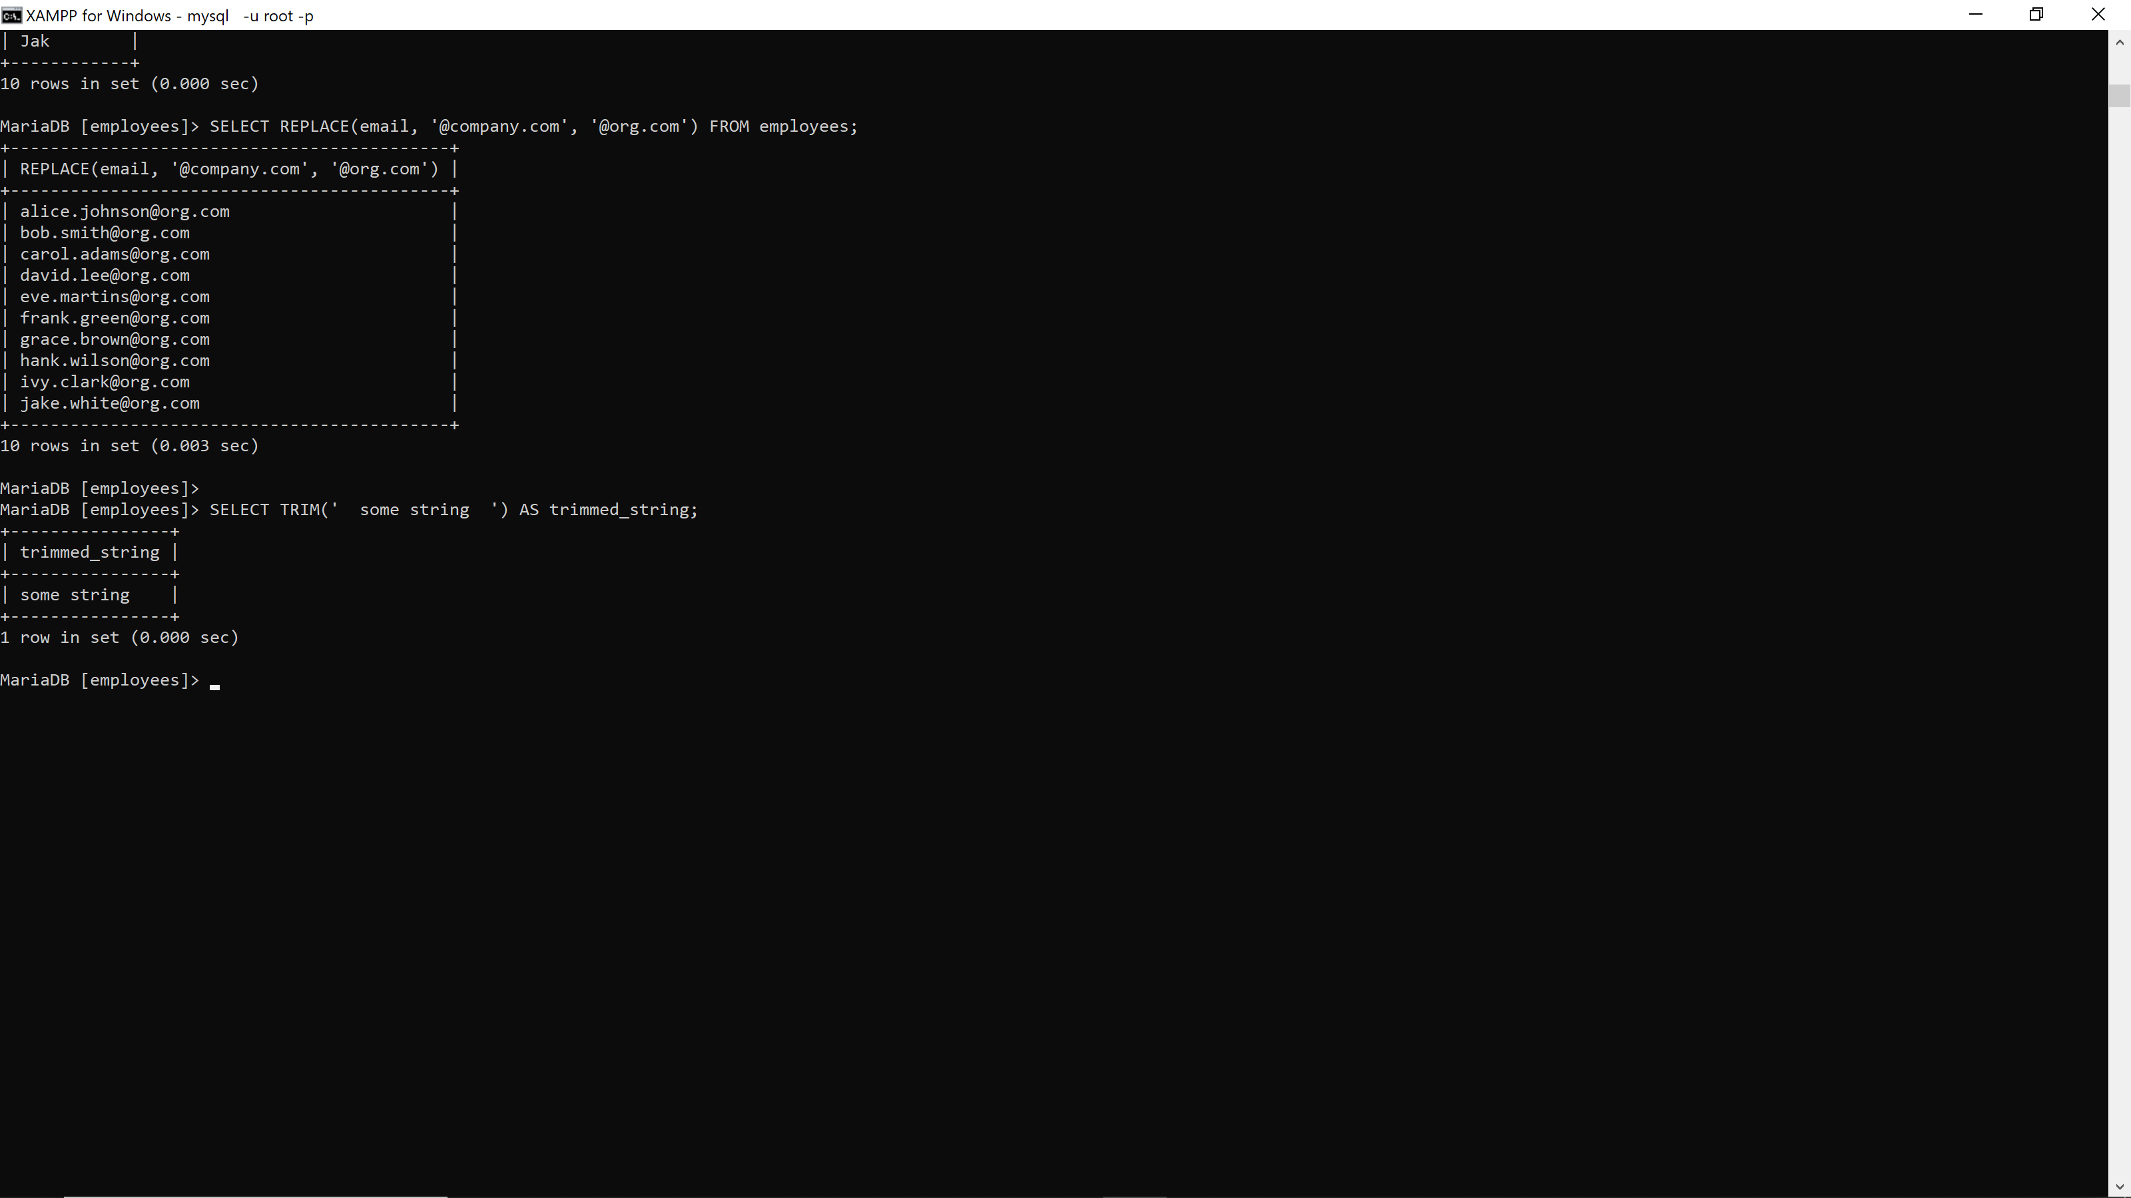

1. SELECT LENGTH(CONCAT(first_name, last_name)) AS name_length FROM employees; **29376**

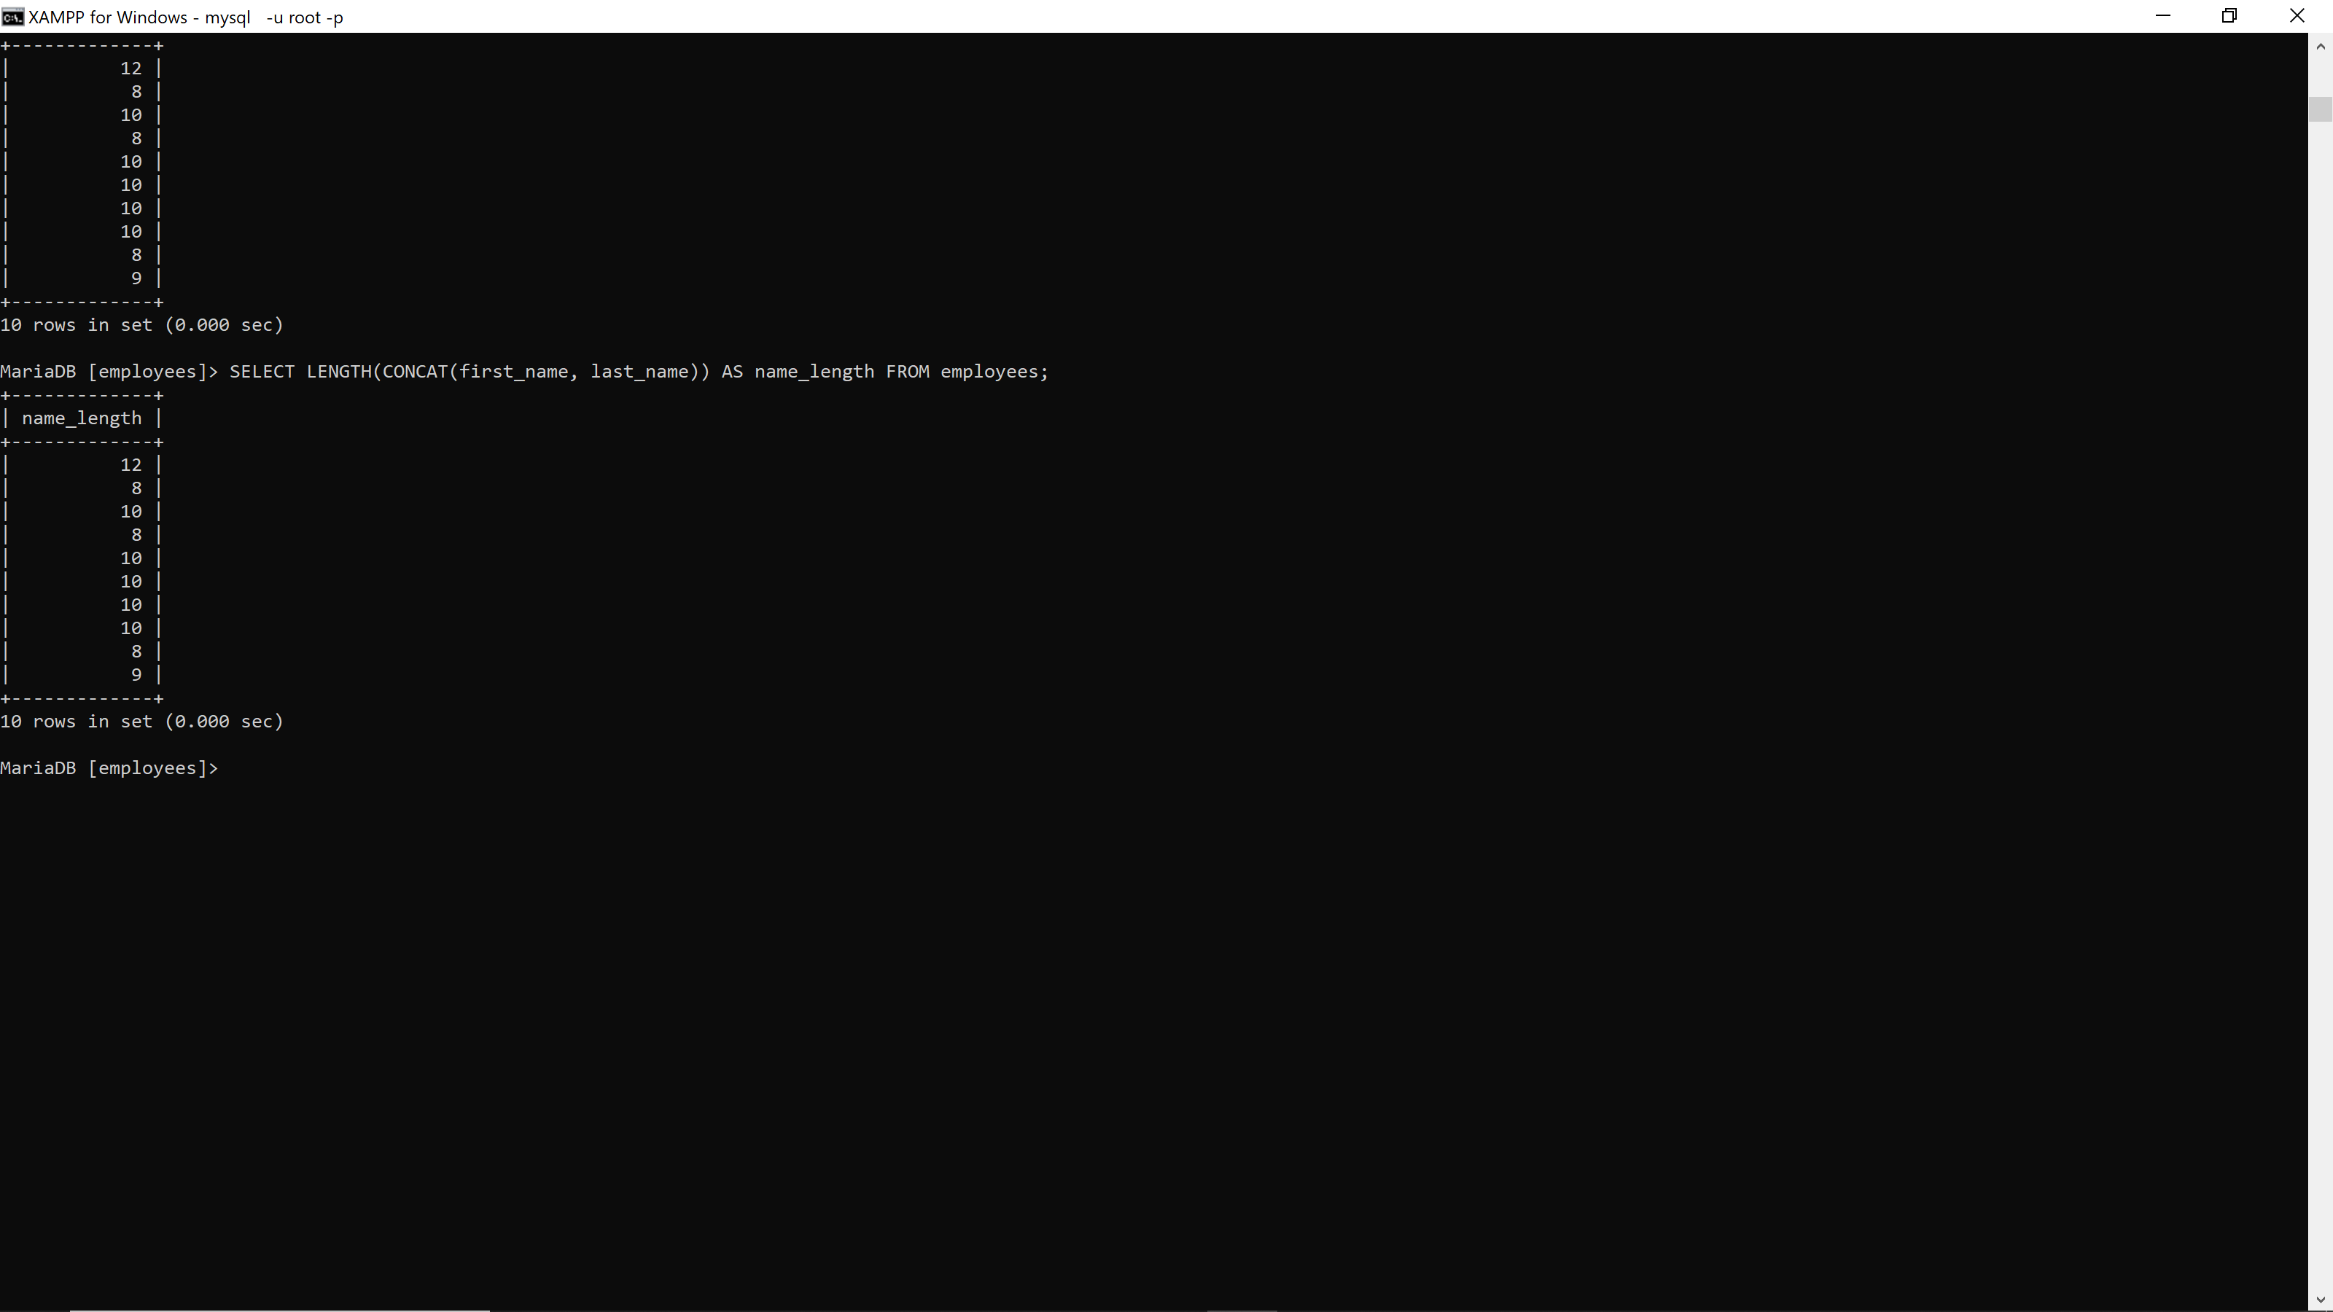

1. SELECT INSTR(email, '@') AS at_position FROM employees; **29376**

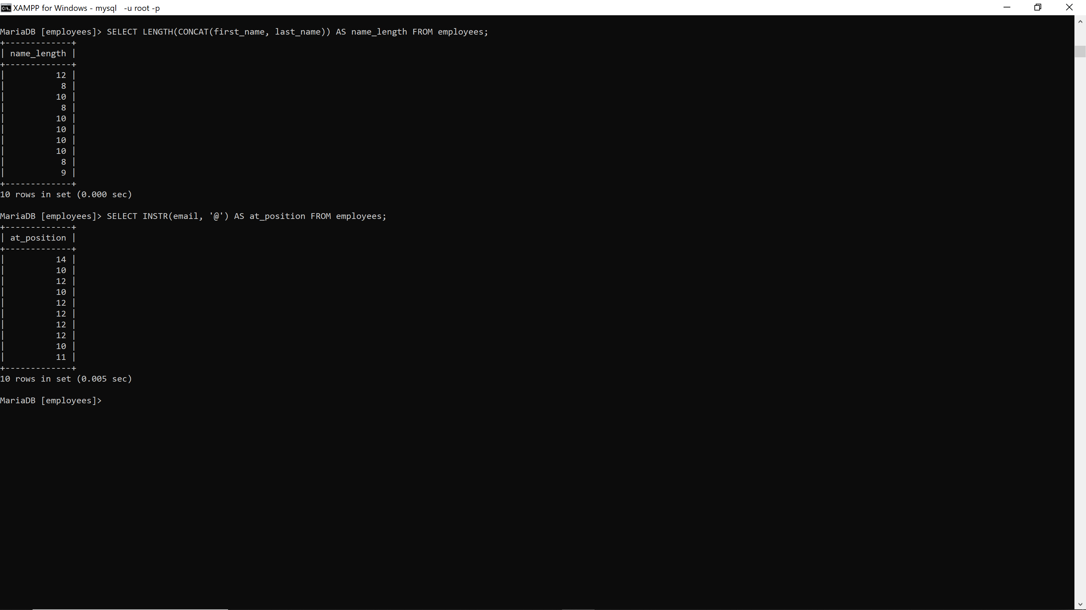

1. SELECT CASE WHEN gender = 'M' THEN CONCAT('Mr. ', first_name) WHEN gender = 'F' THEN CONCAT('Ms. ', first_name) ELSE first_name END FROM employees; **29376**

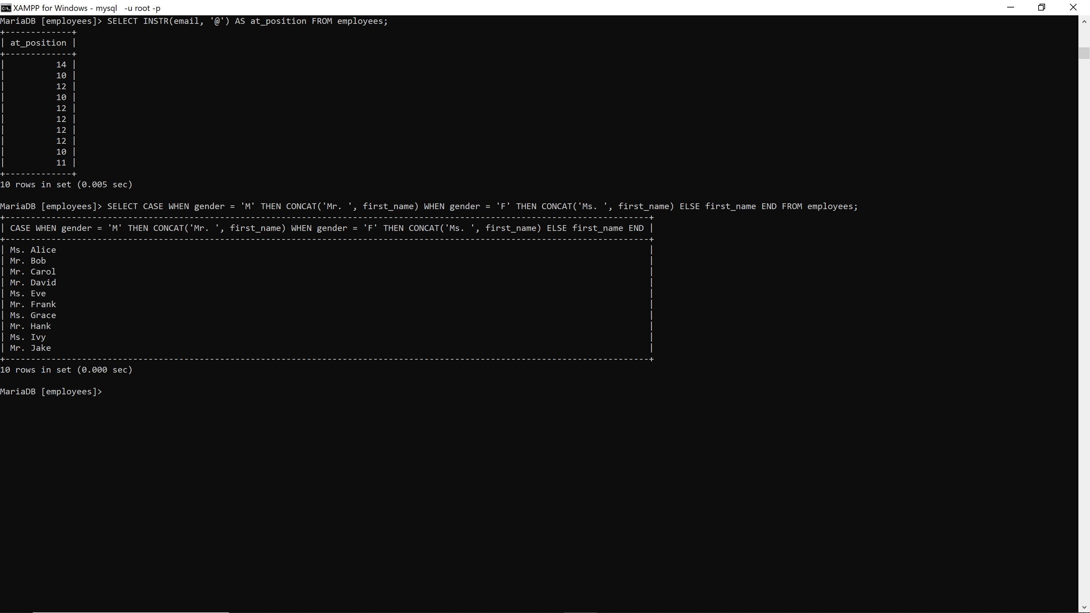

1. SELECT UPPER(project_name) FROM projects; **29376**

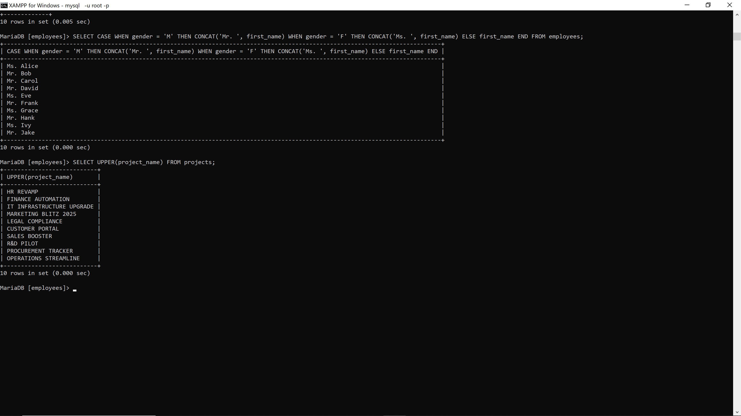

1. SELECT REPLACE(project_name, '-', '') FROM projects; **29376**

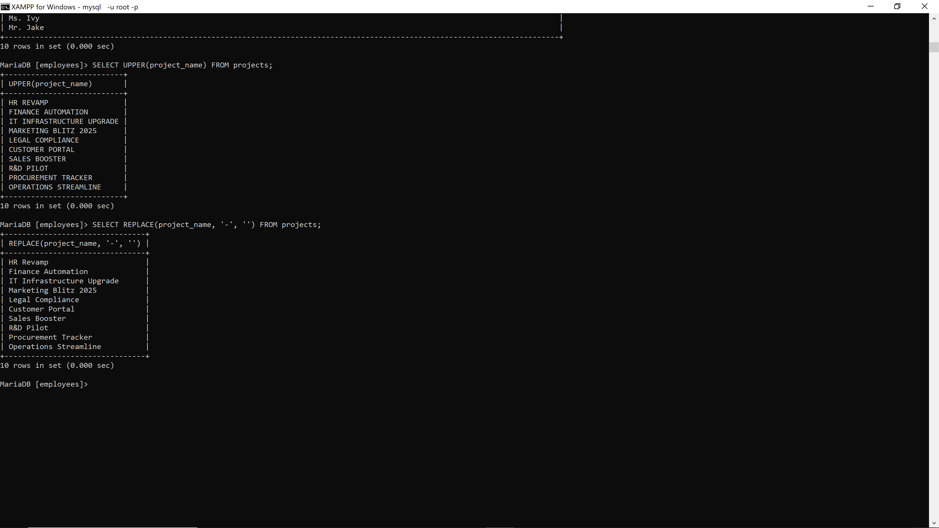

11. SELECT CONCAT('Emp: ', first_name, ' ', last_name, ' (', department_name, ')') FROM employees JOIN departments ON employees.department_id = departments.department_id; **29376**

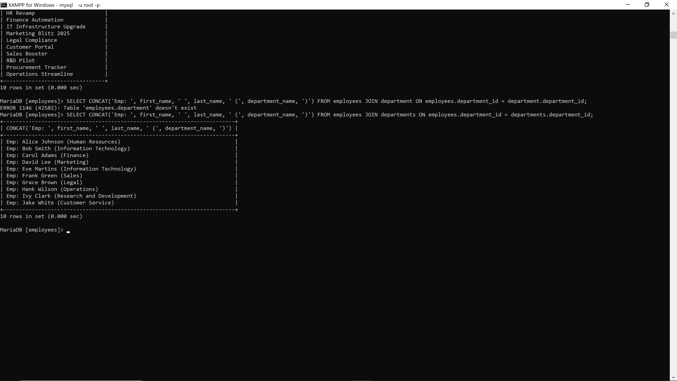

12.SELECT LENGTH(email) FROM employees; **29376**

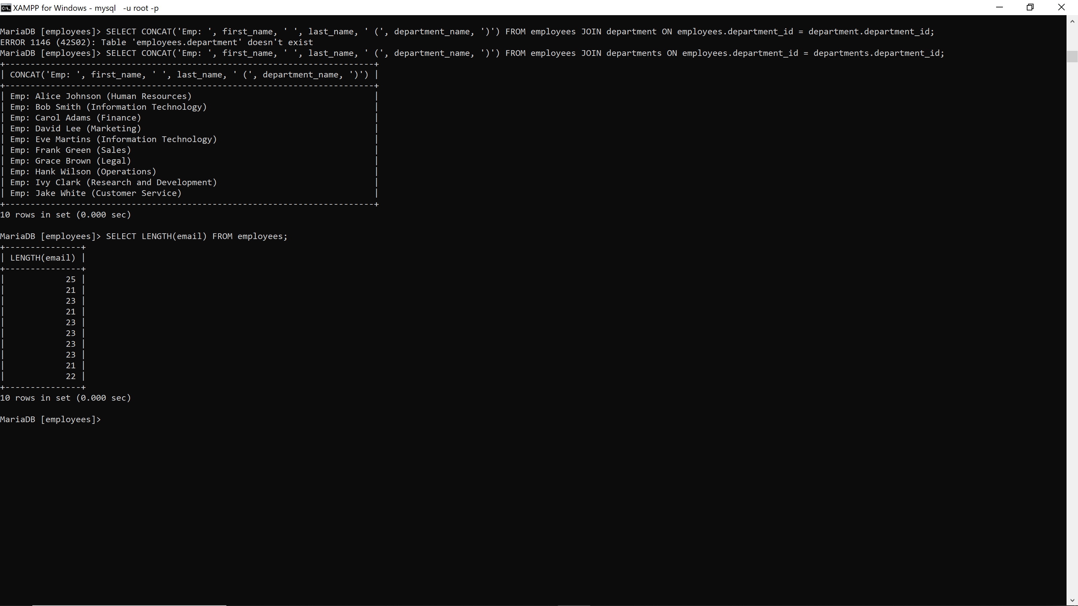

13. SELECT SUBSTRING_INDEX(email, '@', 1) AS lastname_part FROM employees; **29376**

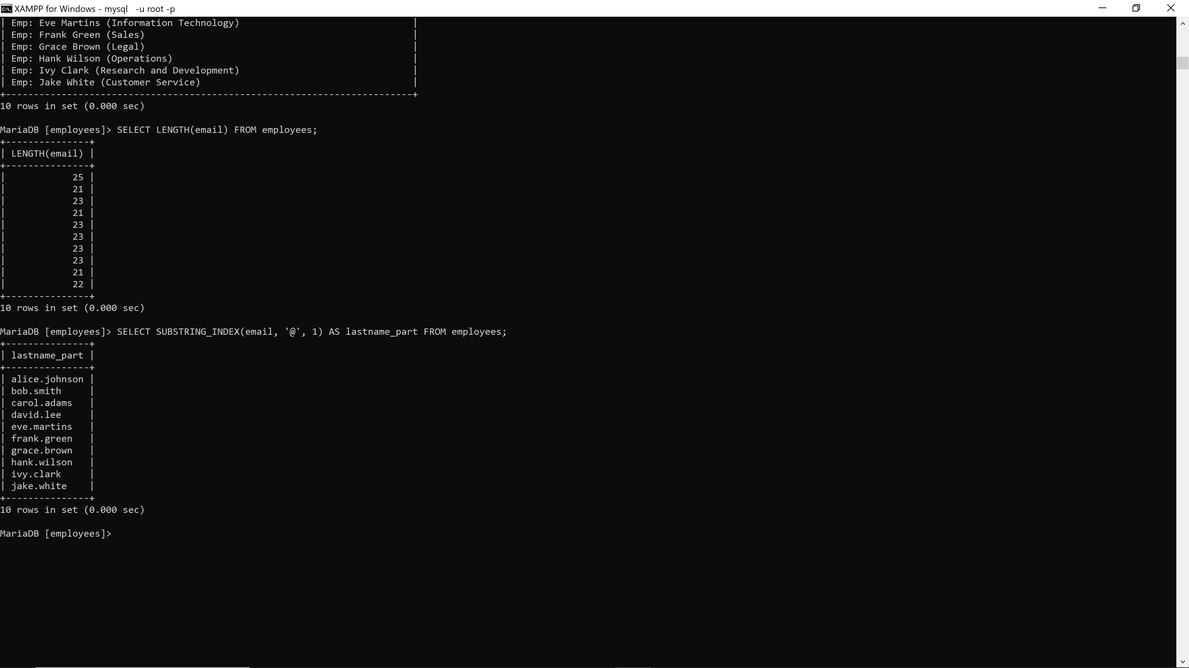

14. SELECT CONCAT(UPPER(last_name), ', ', first_name) AS formatted_name FROM employees; **29376**

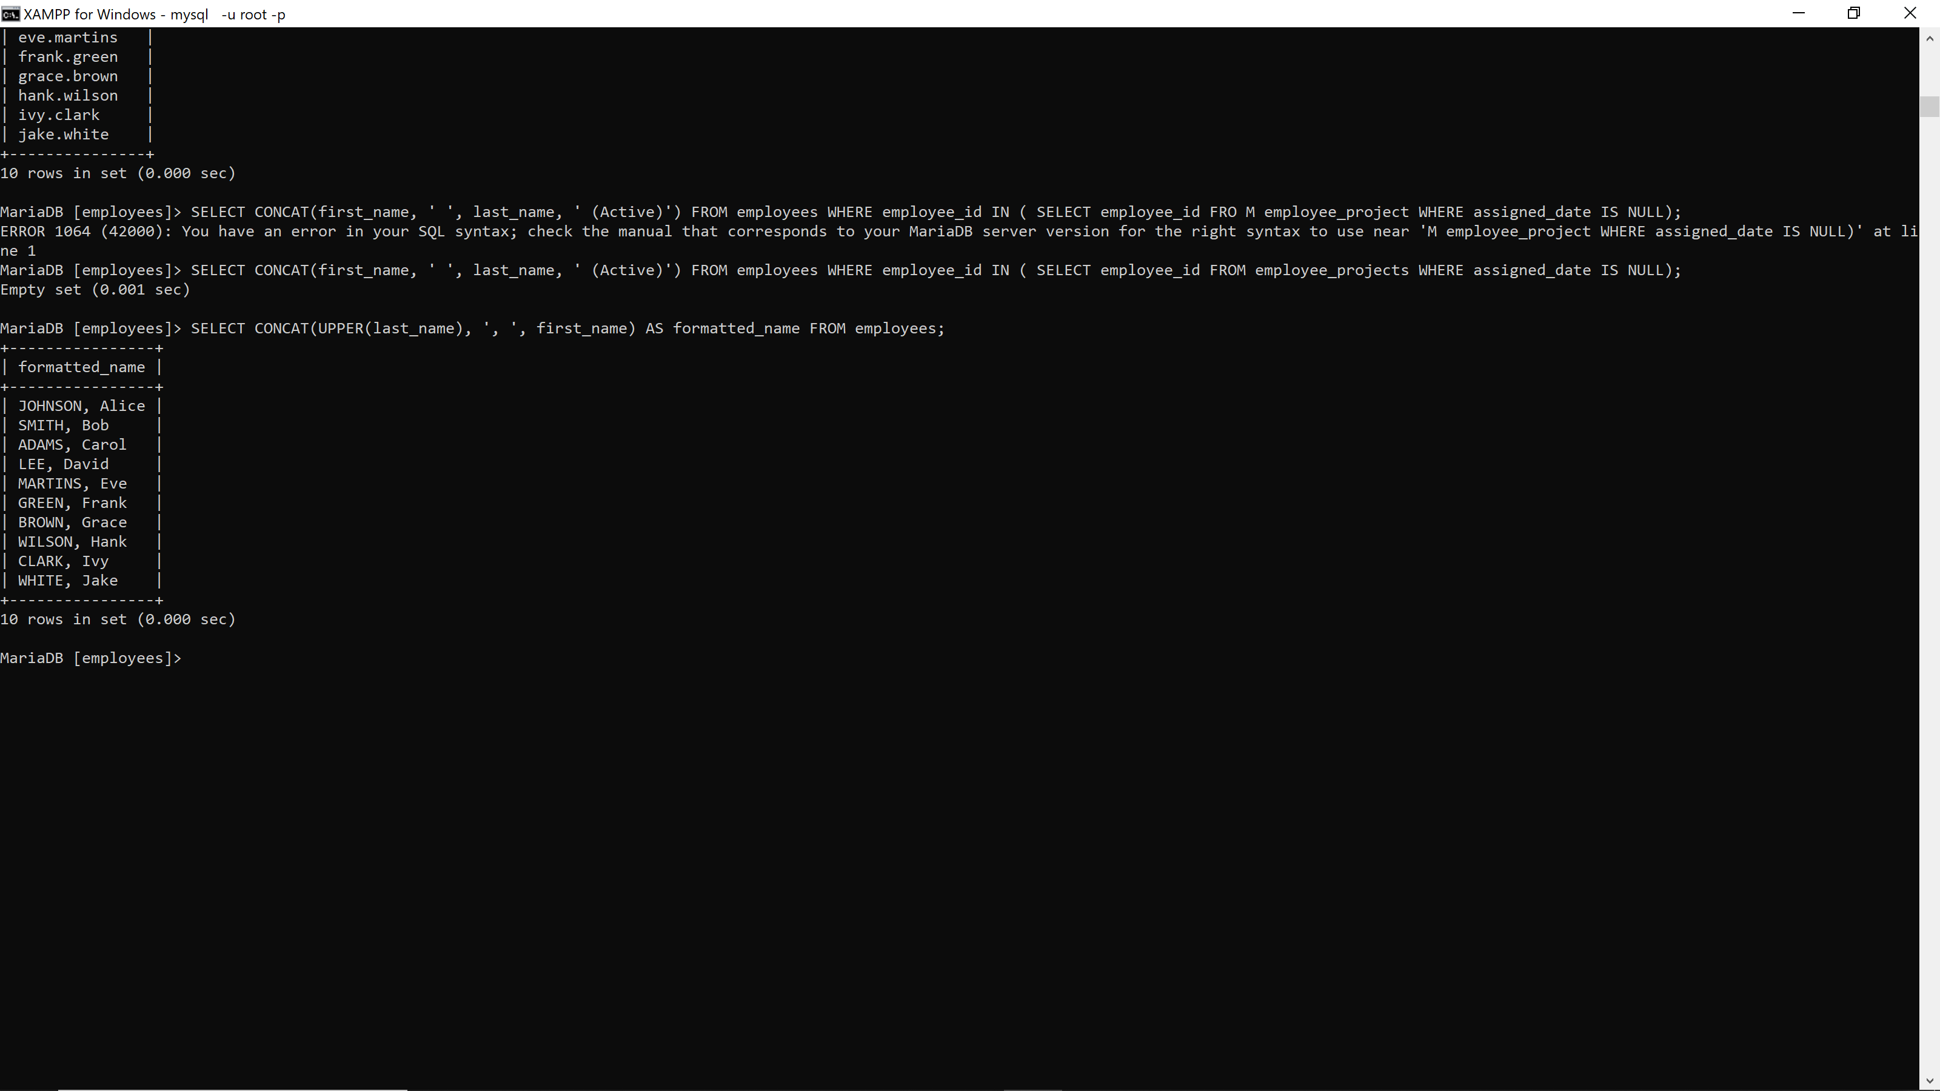

15. SELECT CONCAT(first_name, ' ', last_name, ' (Active)') FROM employees WHERE employee_id IN ( SELECT employee_id FROM employee_projects WHERE assigned_date IS NULL); **29376**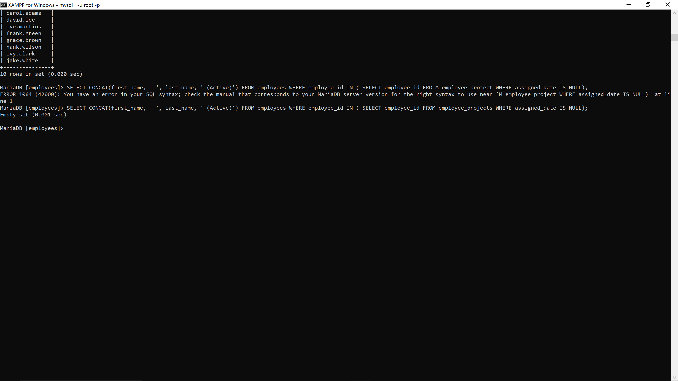

**PART 2:Numeric Function Exercises**

16. SELECT ROUND(salary) FROM employees**29376**

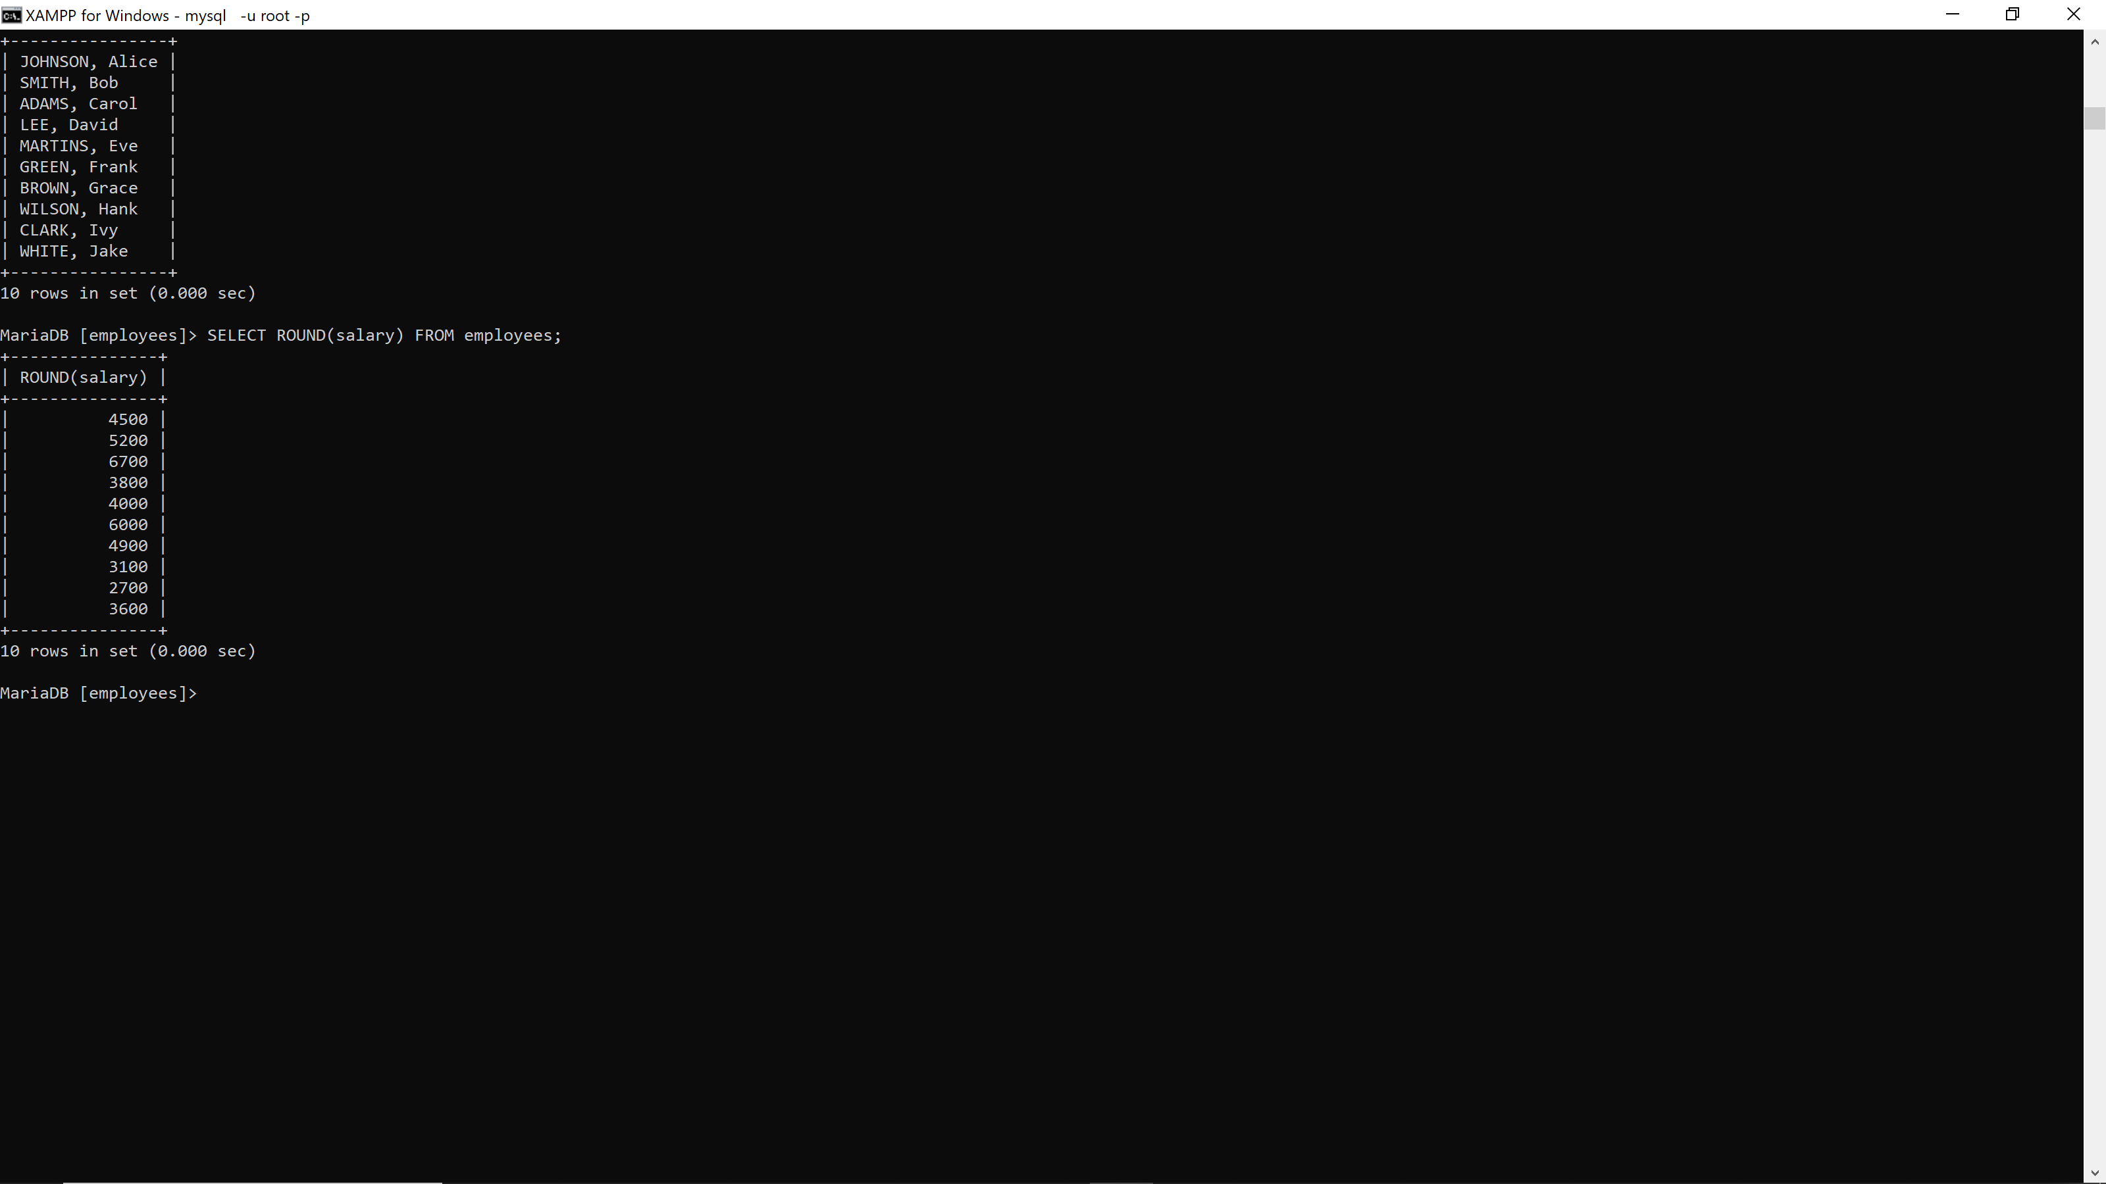

17. SELECT salary FROM employees WHERE MOD(salary, 2) = 0; **29376**

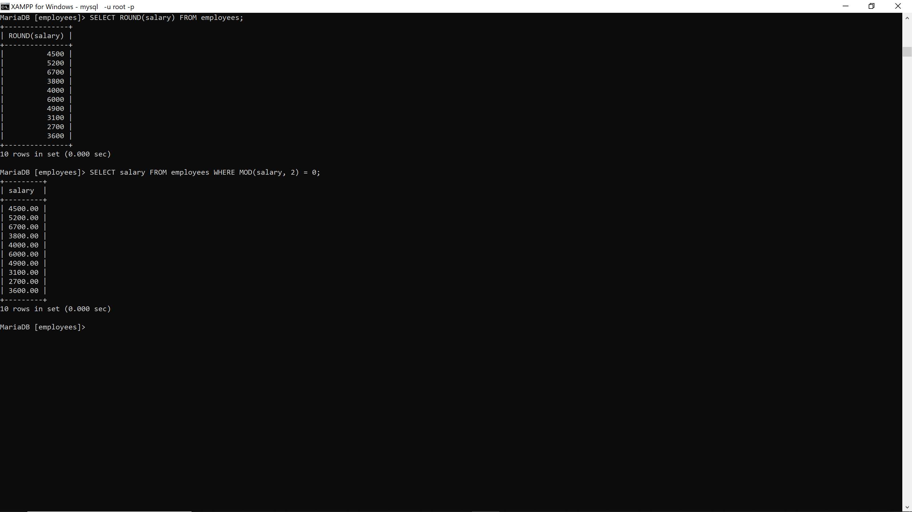

18. SELECT DATEDIFF(end_date, start_date) FROM projects; **29376**

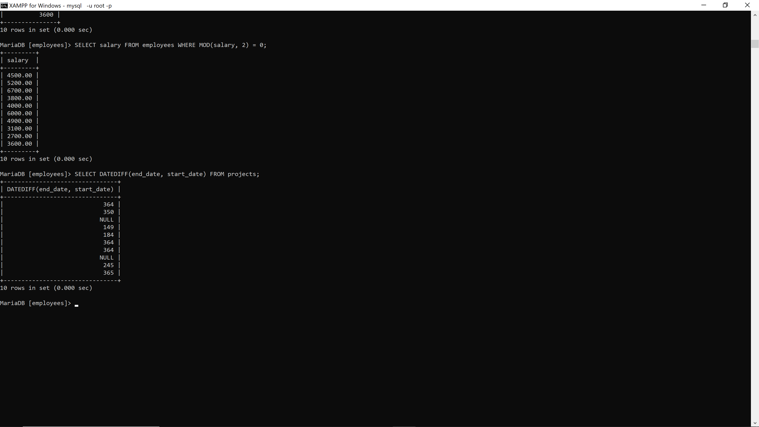

19. SELECT ABS((SELECT salary FROM employees WHERE employee_id = 101) - (SELECT salary FROM employees WHERE employee_id = 102)); **29376**

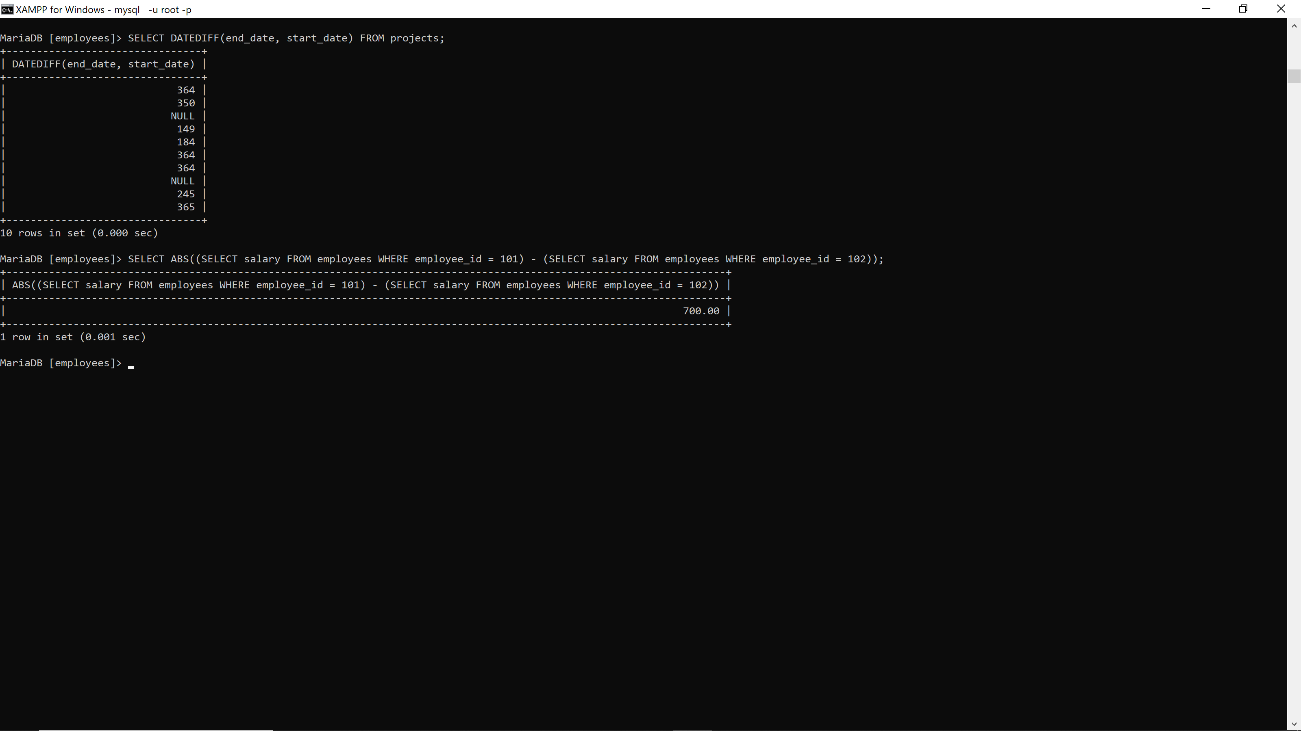

20. SELECT salary * POWER(1.1, 1) AS increased_salary FROM employees; **29376**

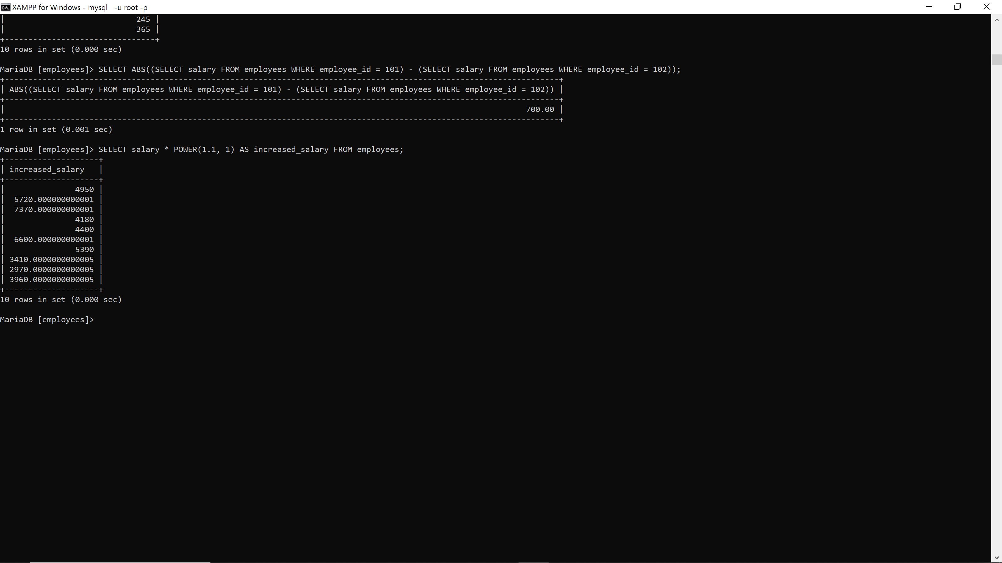

21. SELECT RAND();**29376**

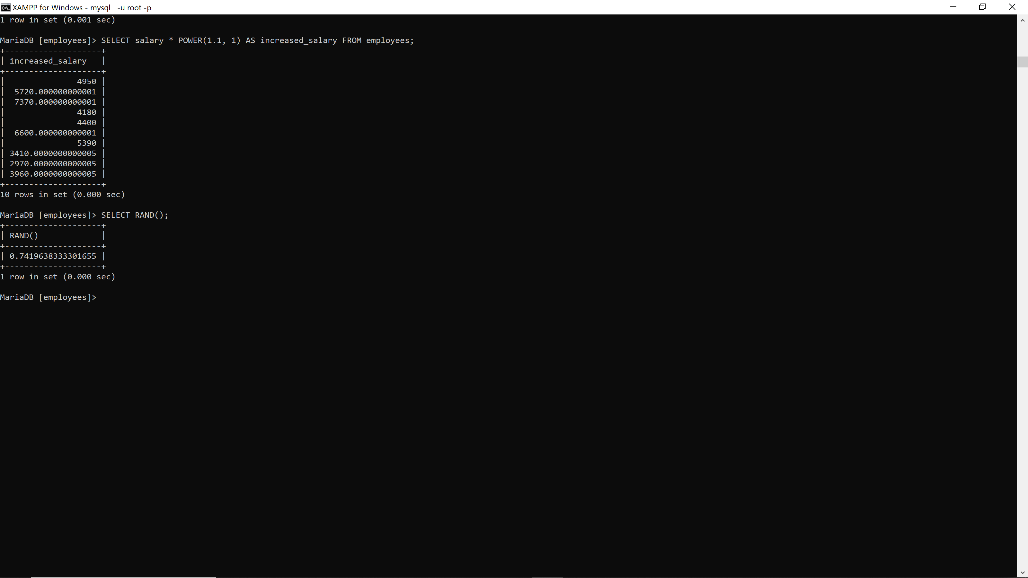

22. SELECT CEIL(salary), FLOOR(salary) FROM employees; **29376**

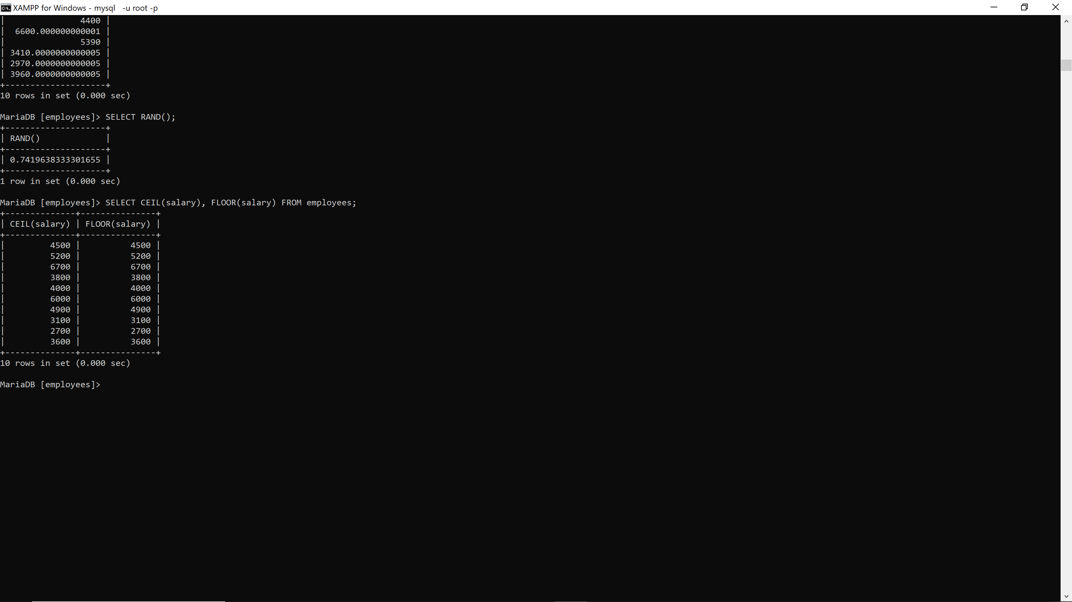

23. SELECT LENGTH(phone_number) FROM employees; **29376**

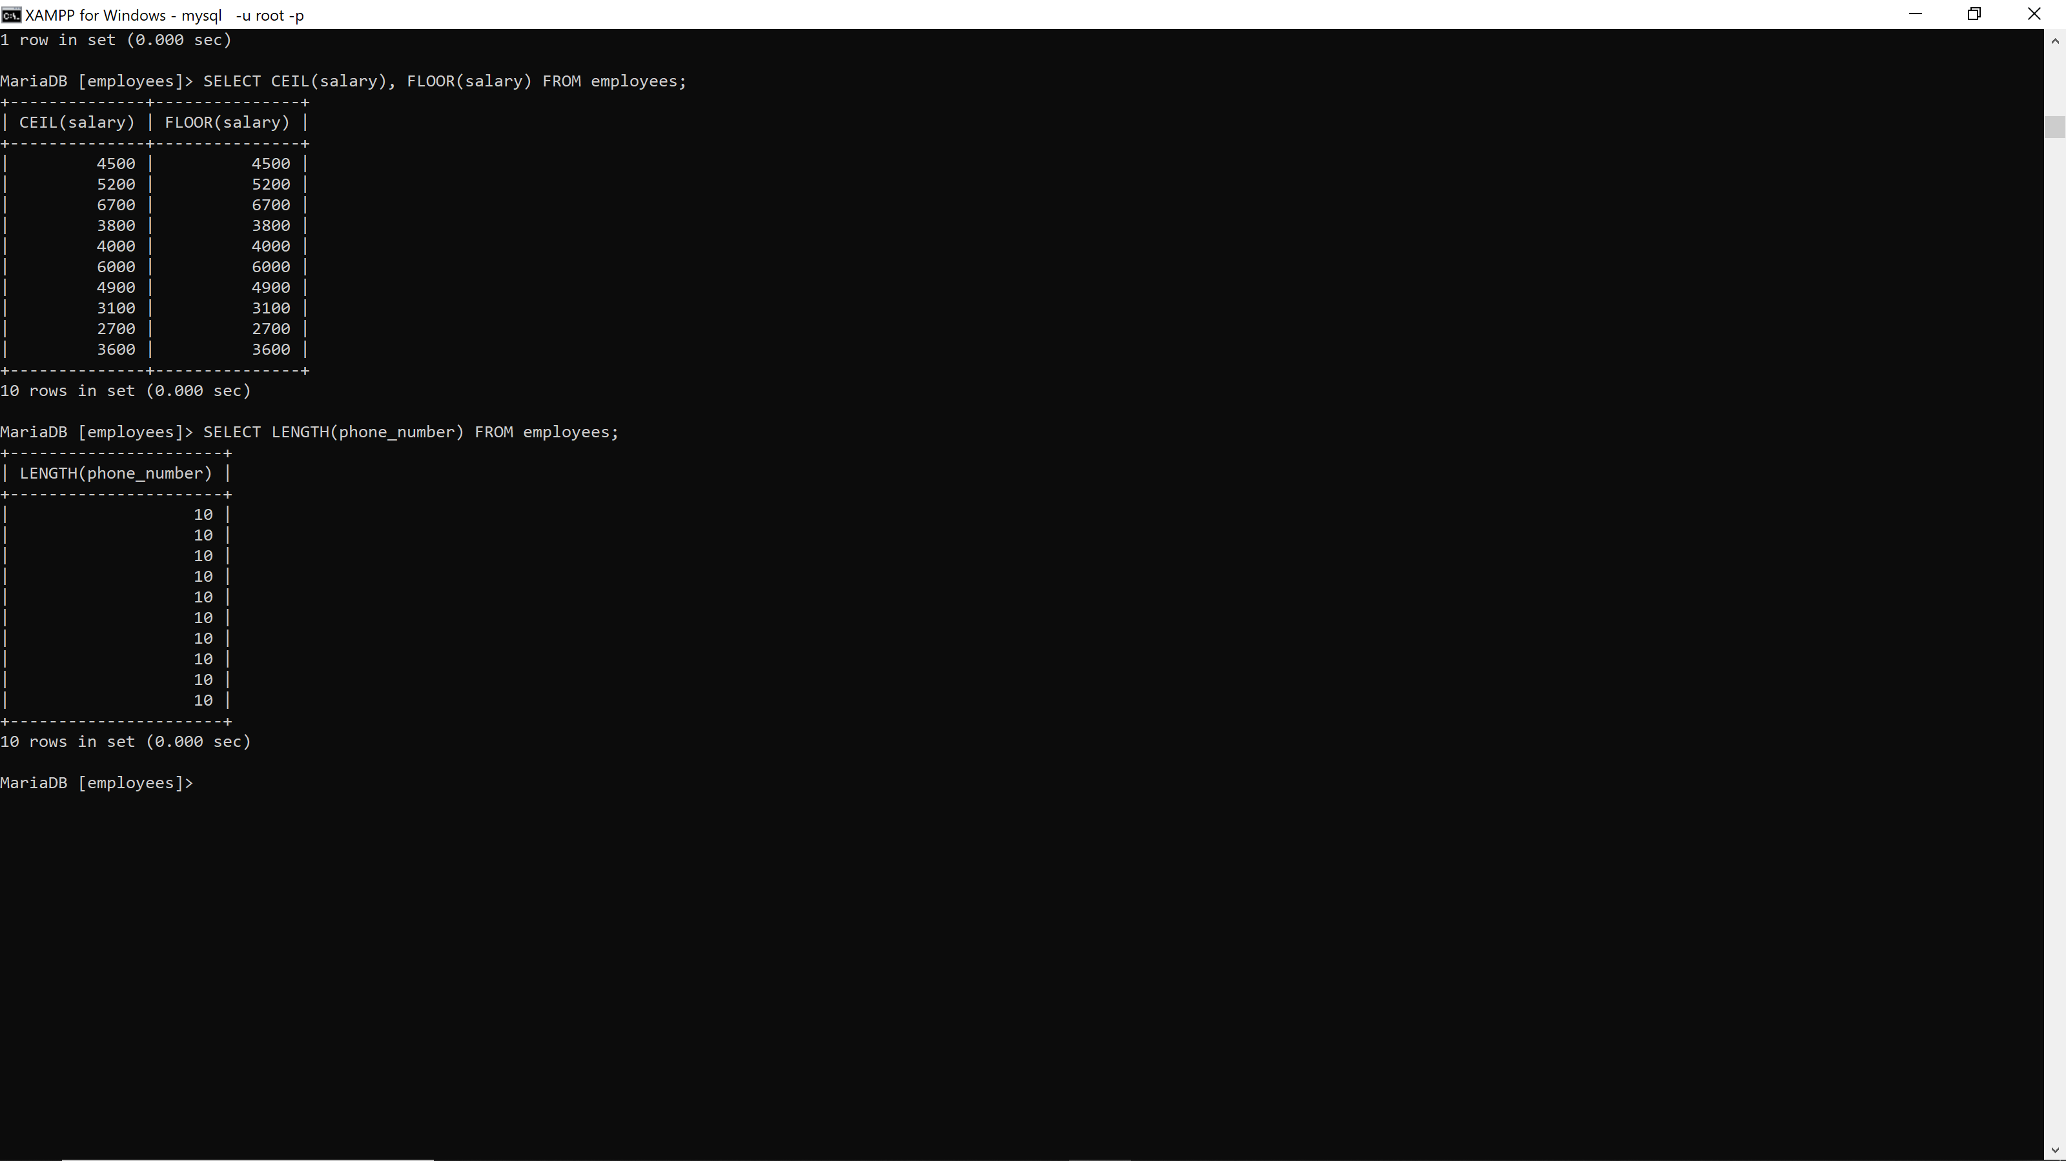

24. SELECT CASE WHEN salary >= 5000 THEN 'High' WHEN salary >= 3000 THEN 'Medium' ELSE 'Low' END AS salary_category FROM employees; **29376**  
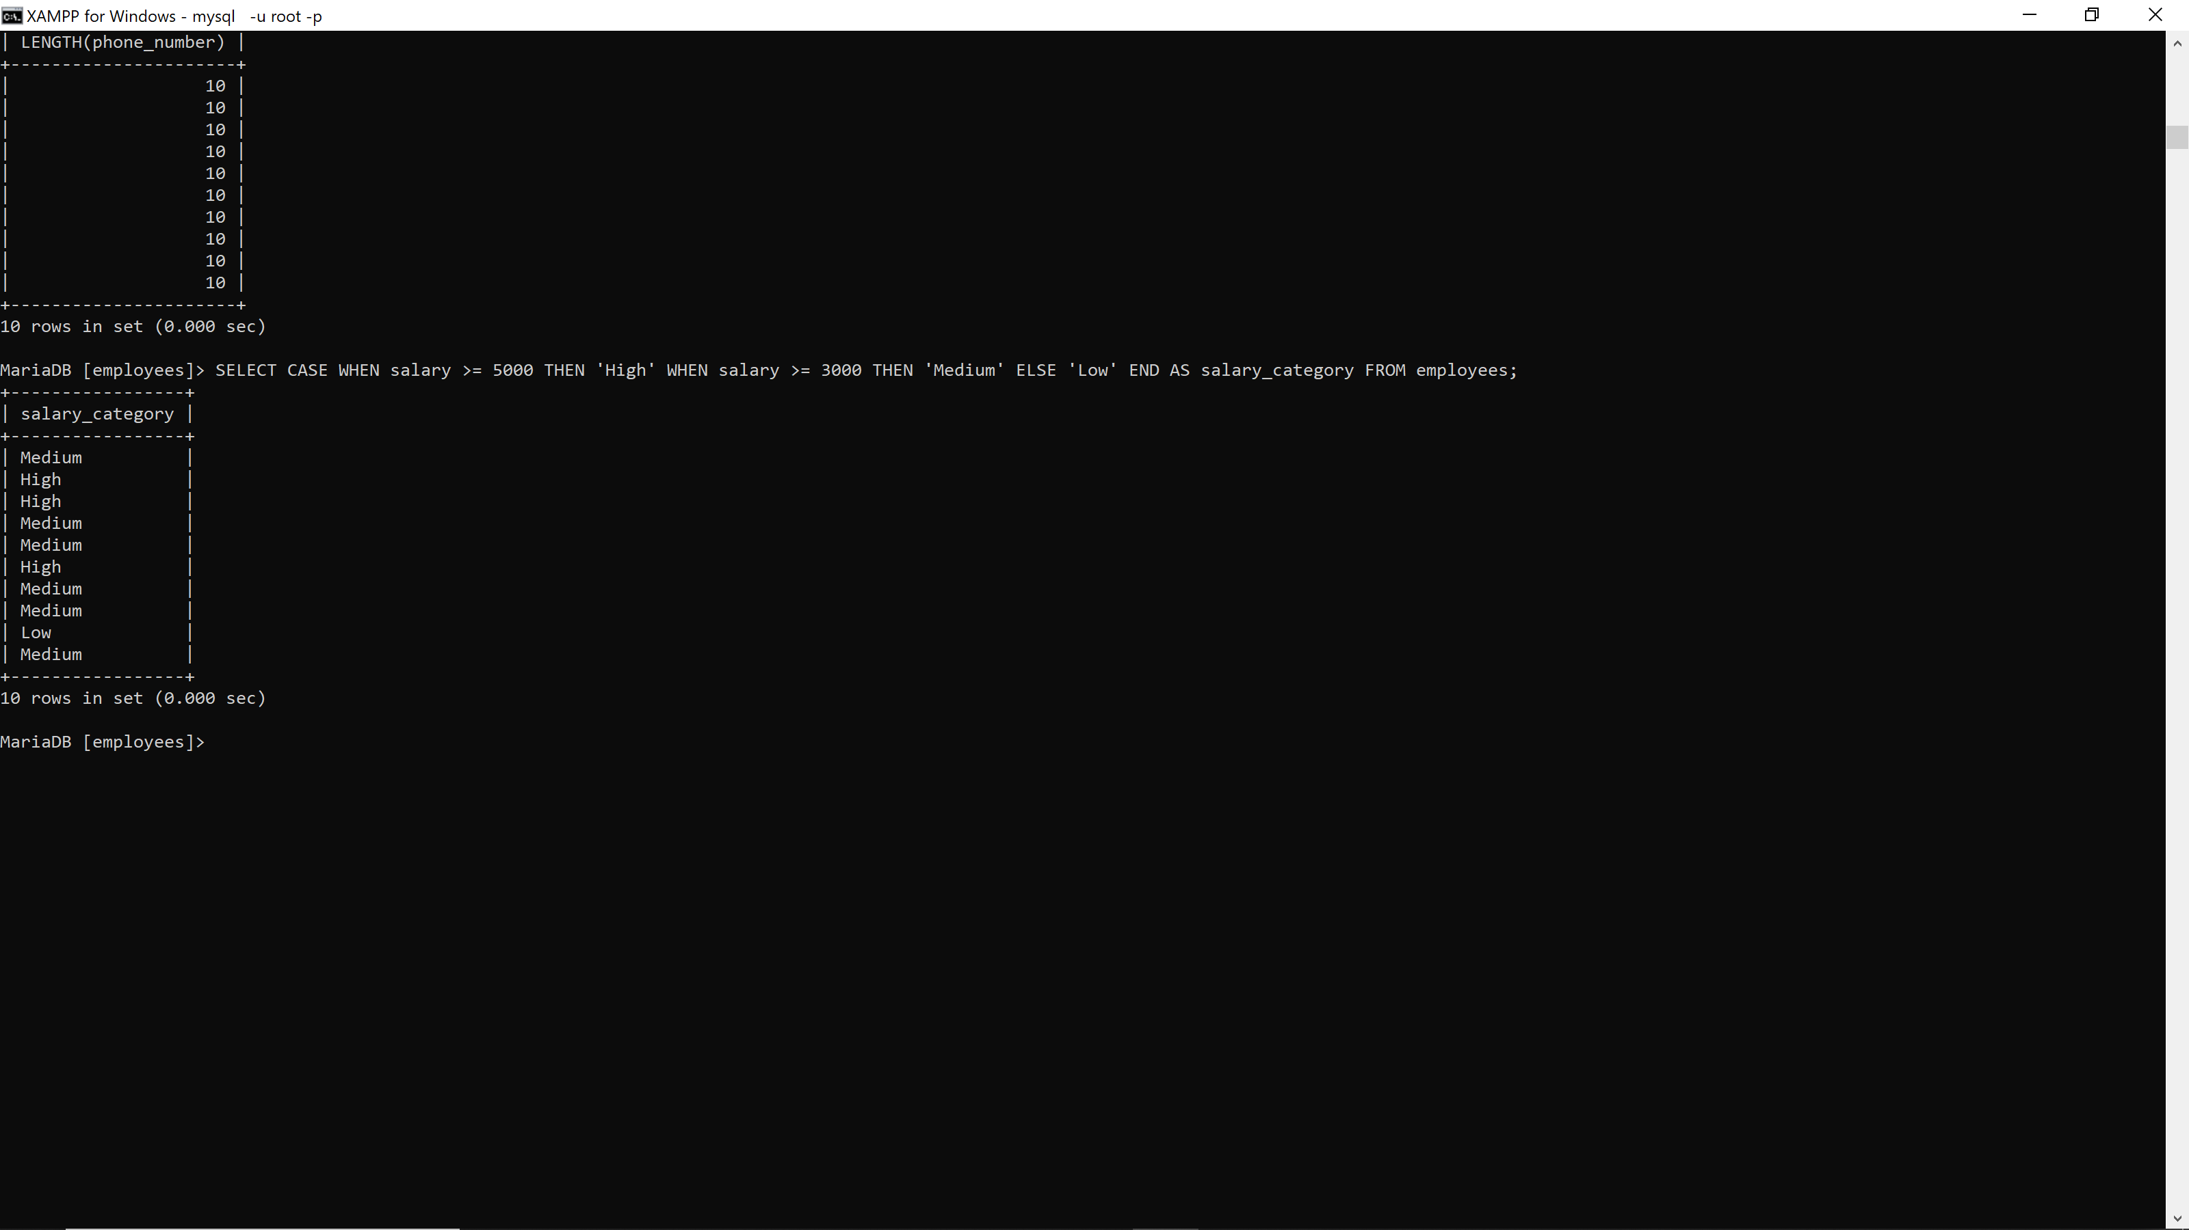

25. SELECT LENGTH(CAST(salary AS CHAR)) AS digit_count FROM employees; **29376**

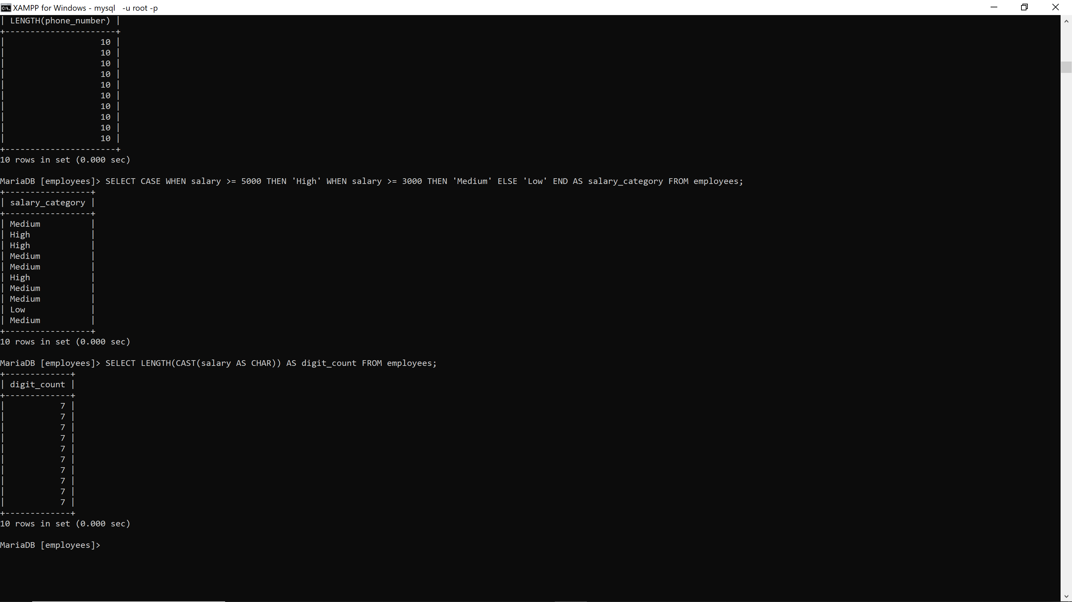

**PART 3:Date/Time Function Exercises**

26. SELECT CURRENT_DATE; **29376**

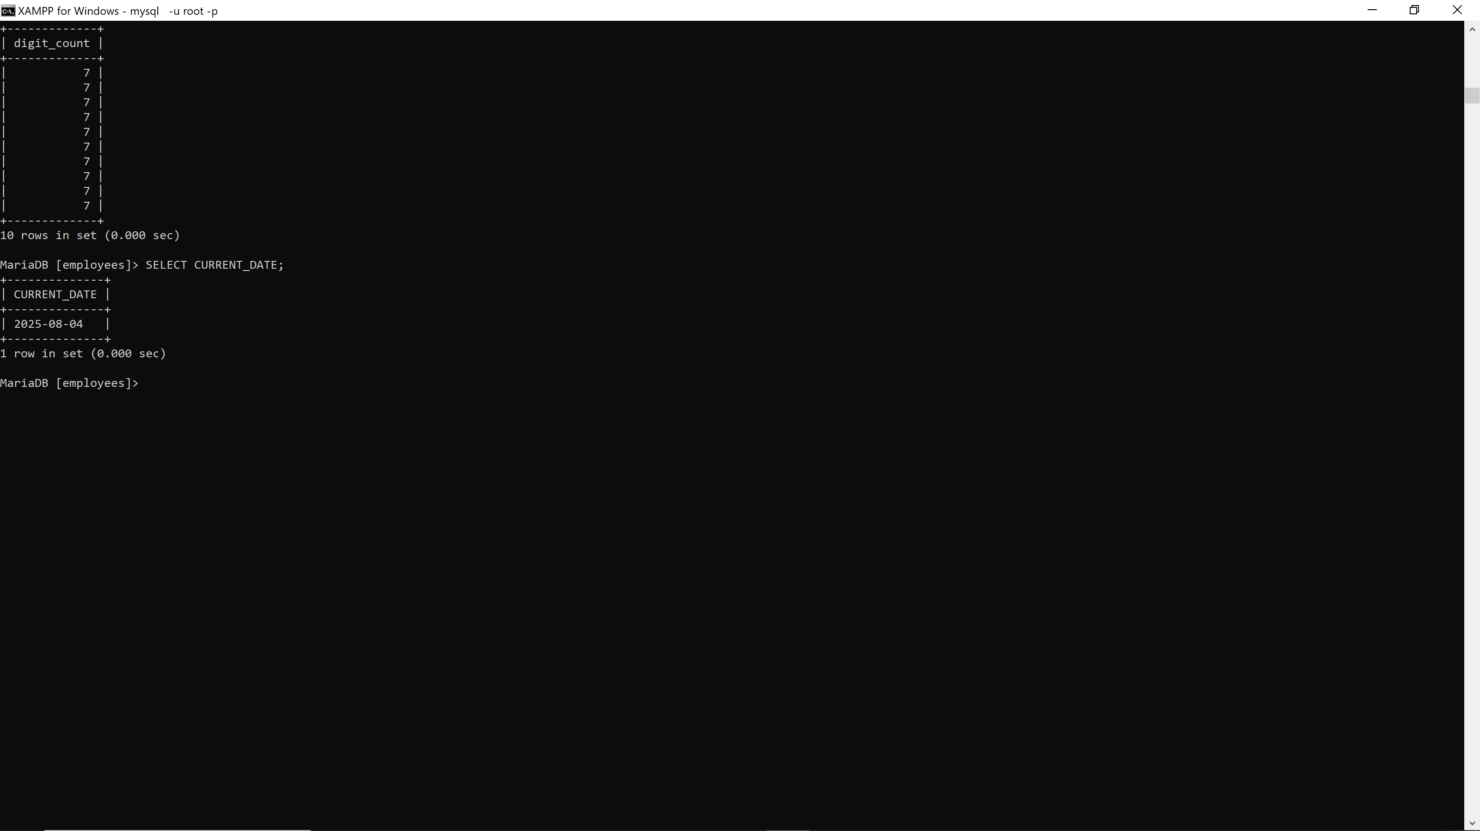

27. SELECT DATEDIFF(CURRENT_DATE, hire_date) AS days_worked FROM employees; **29376**

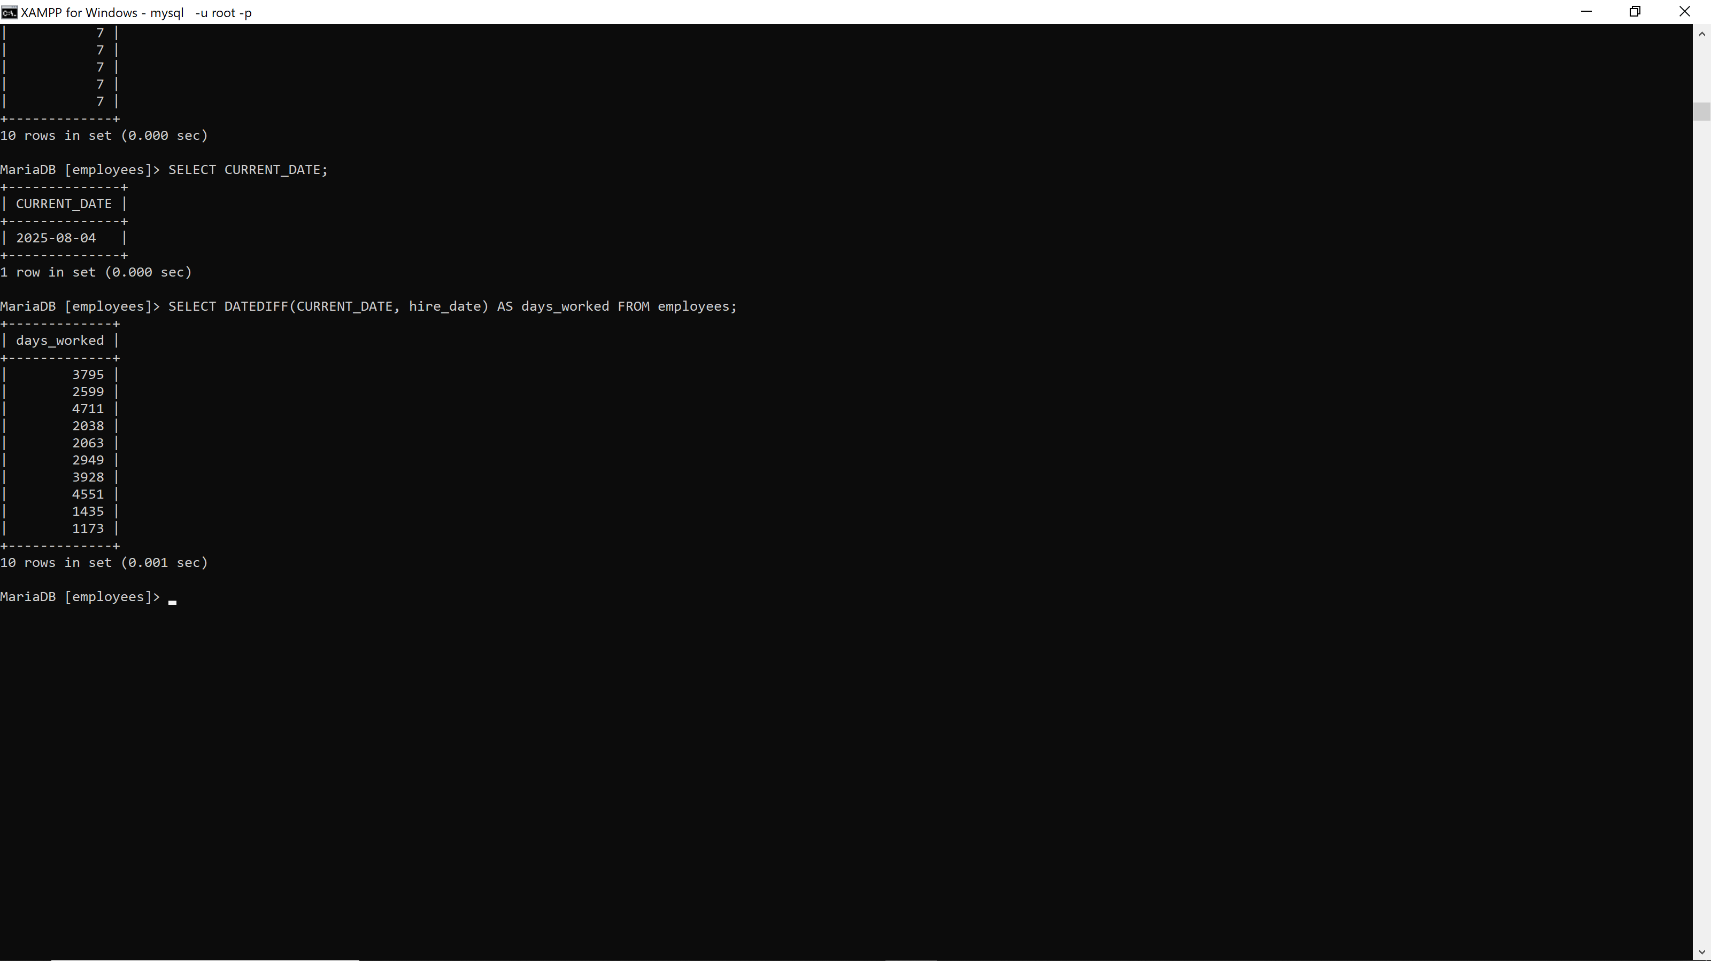

28. SELECT * FROM employees WHERE YEAR(hire_date) = YEAR(CURRENT_DATE); **29376**

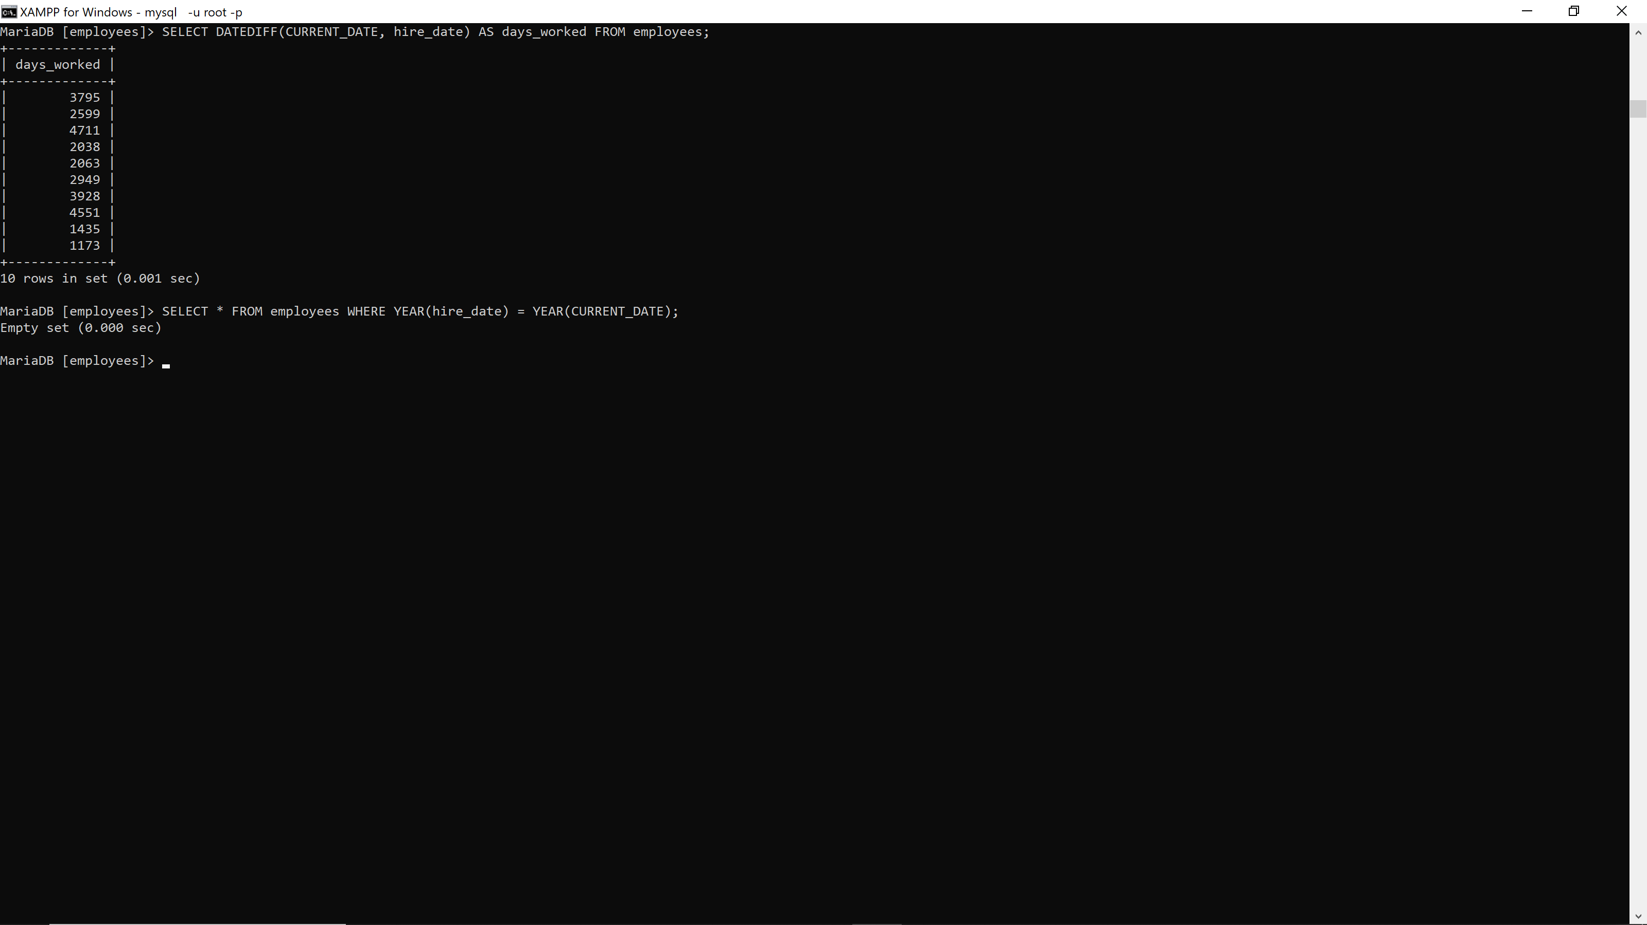

29. SELECT NOW();**29376**

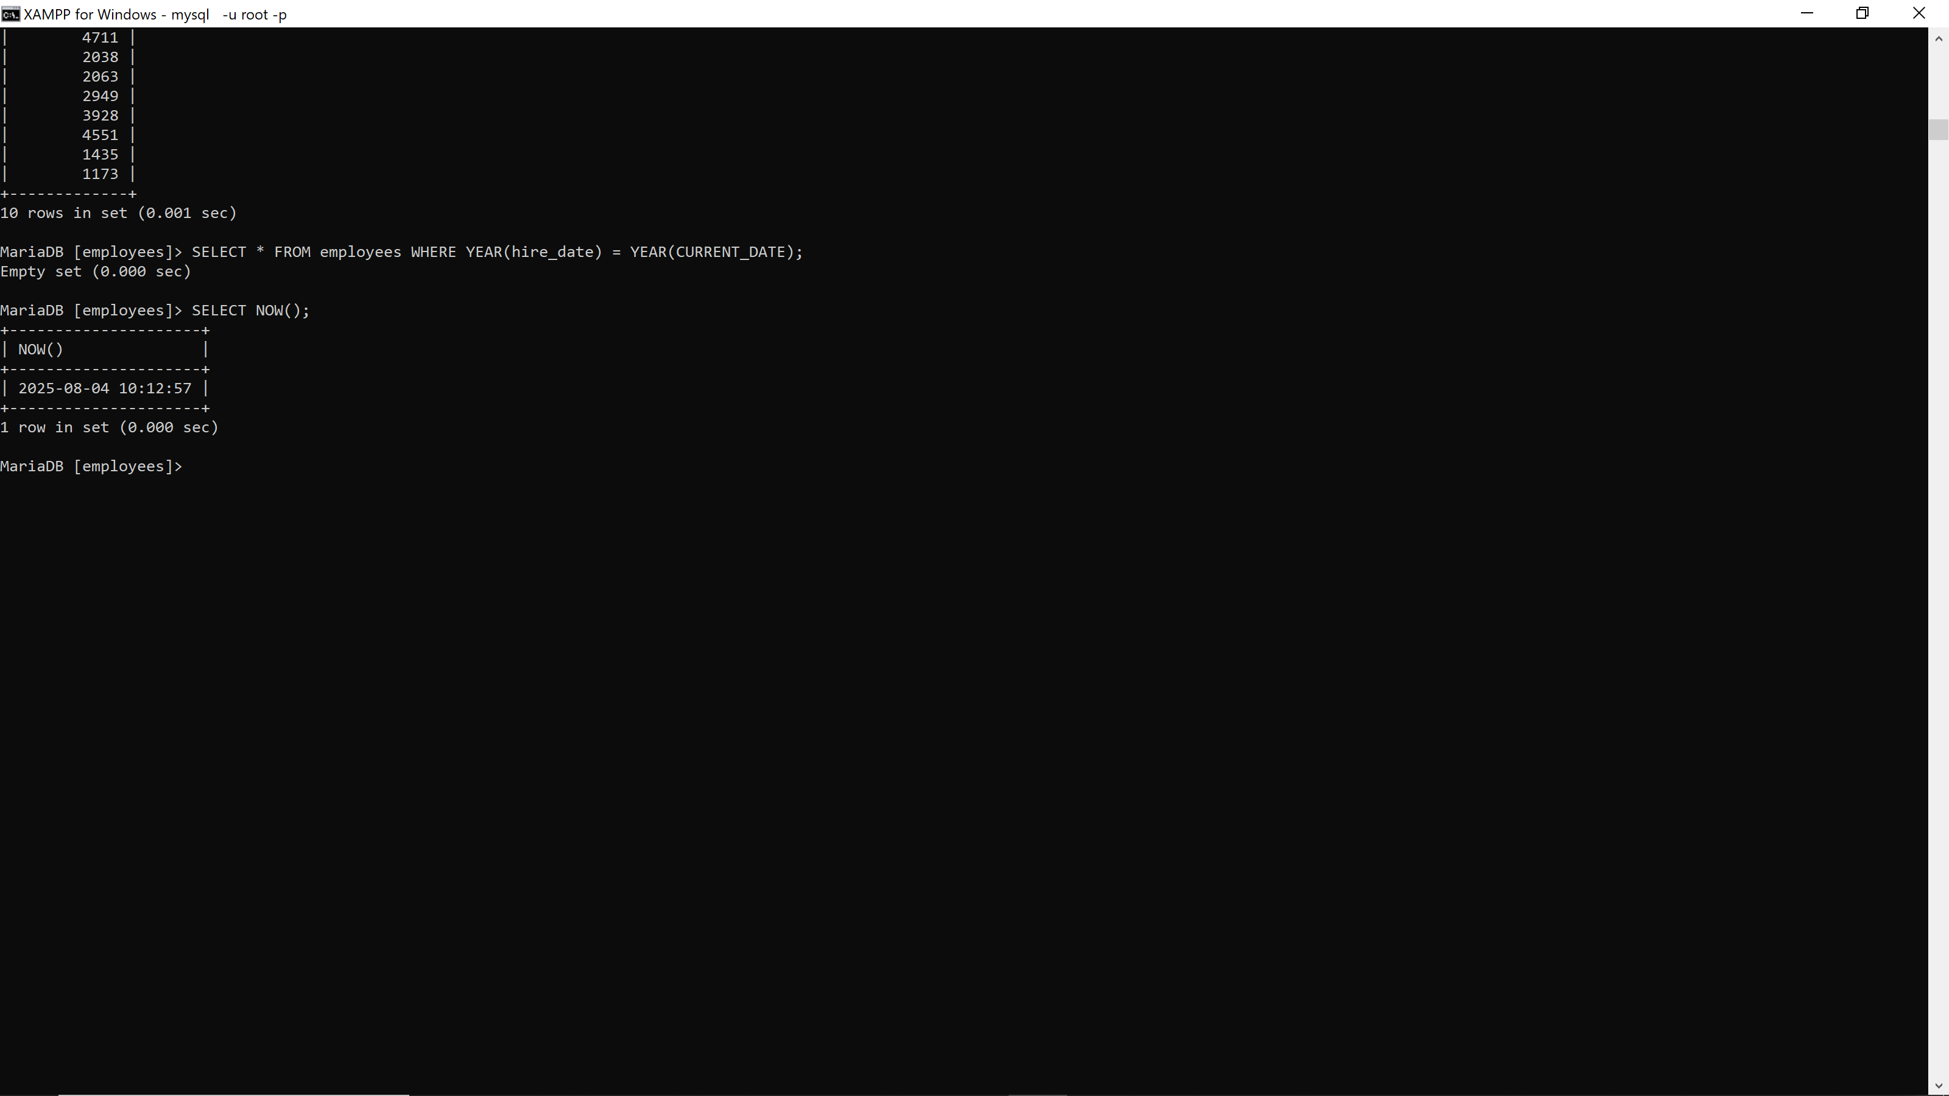

30. SELECT YEAR(hire_date), MONTH(hire_date), DAY(hire_date) FROM employees; **29376**

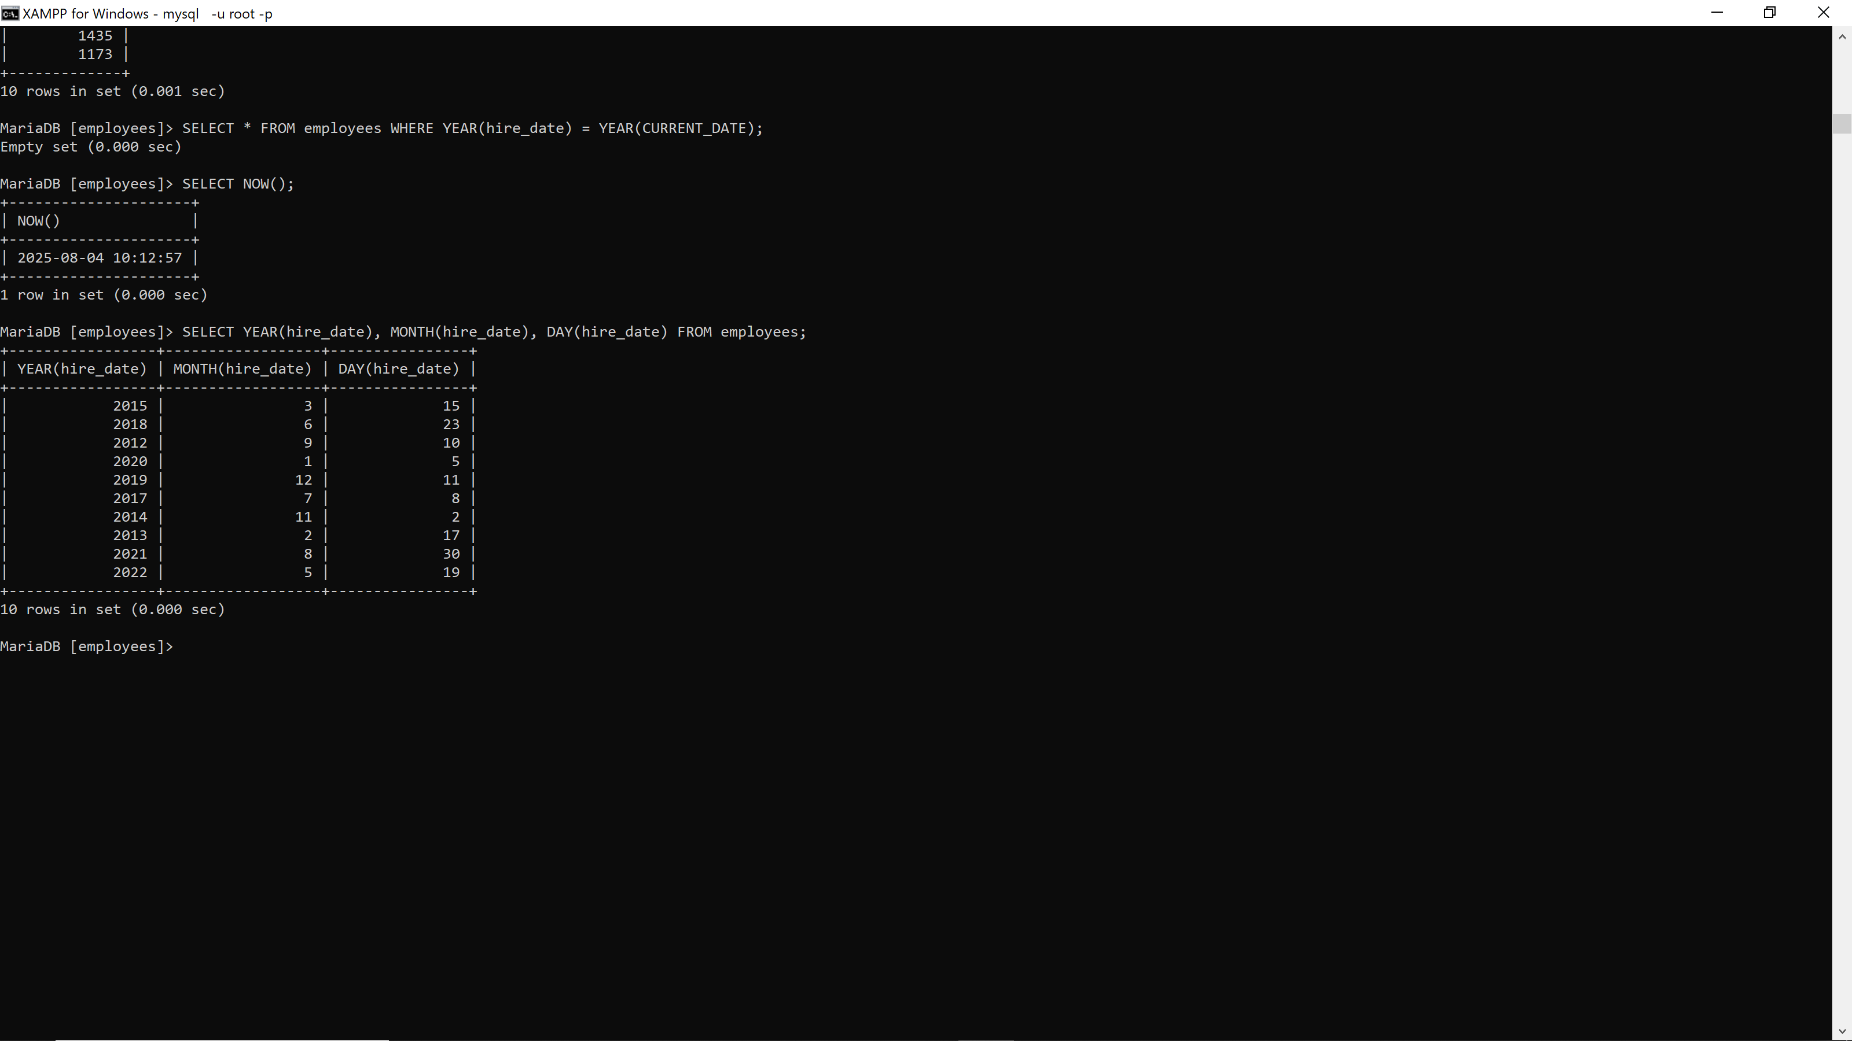

31. SELECT * FROM employees WHERE hire_date < '2020-01-01'; **29376**

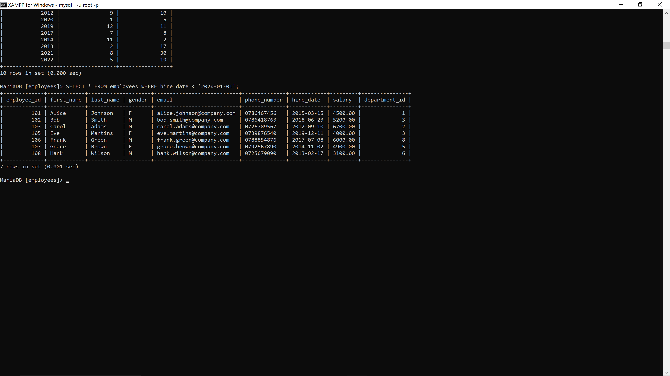

32. SELECT * FROM projects WHERE end_date BETWEEN DATE_SUB(CURDATE(), INTERVAL 30 DAY) AND CURDATE();**29376**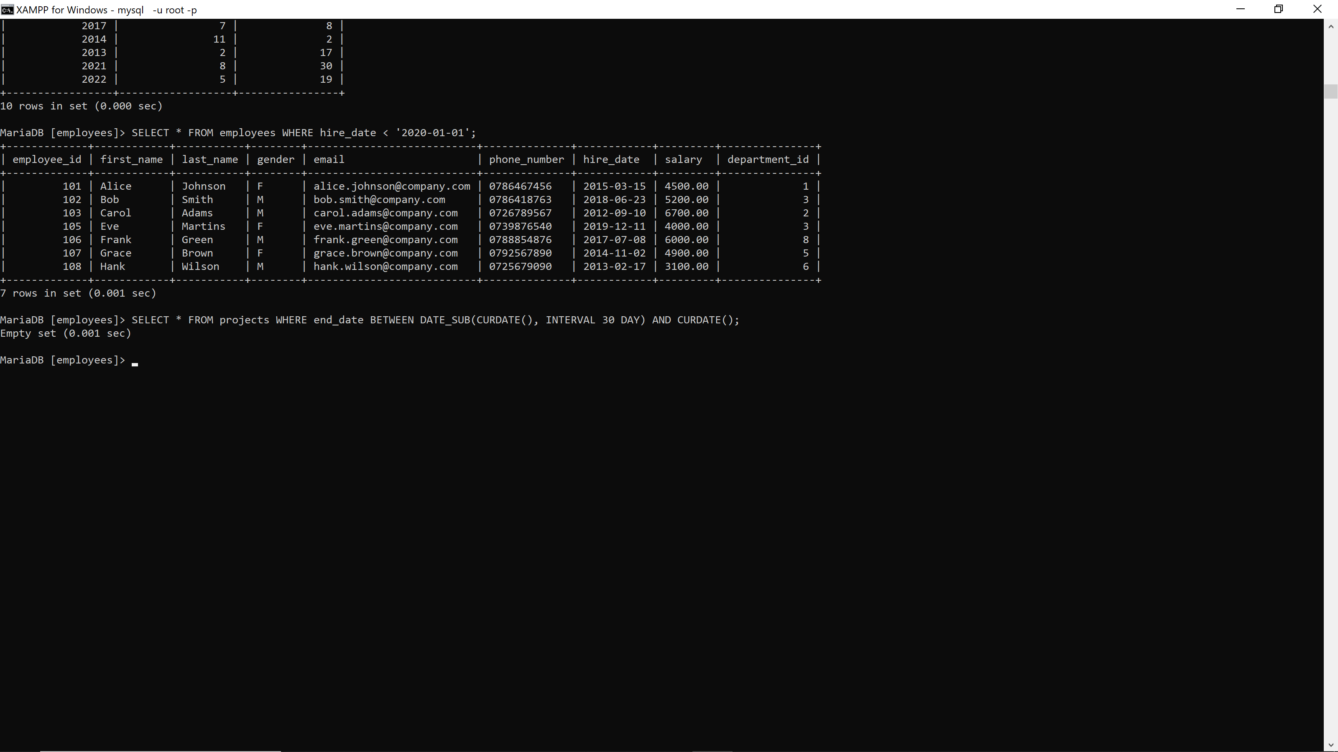

33. SELECT DATEDIFF(end_date, start_date) AS duration_days FROM projects; **29376**

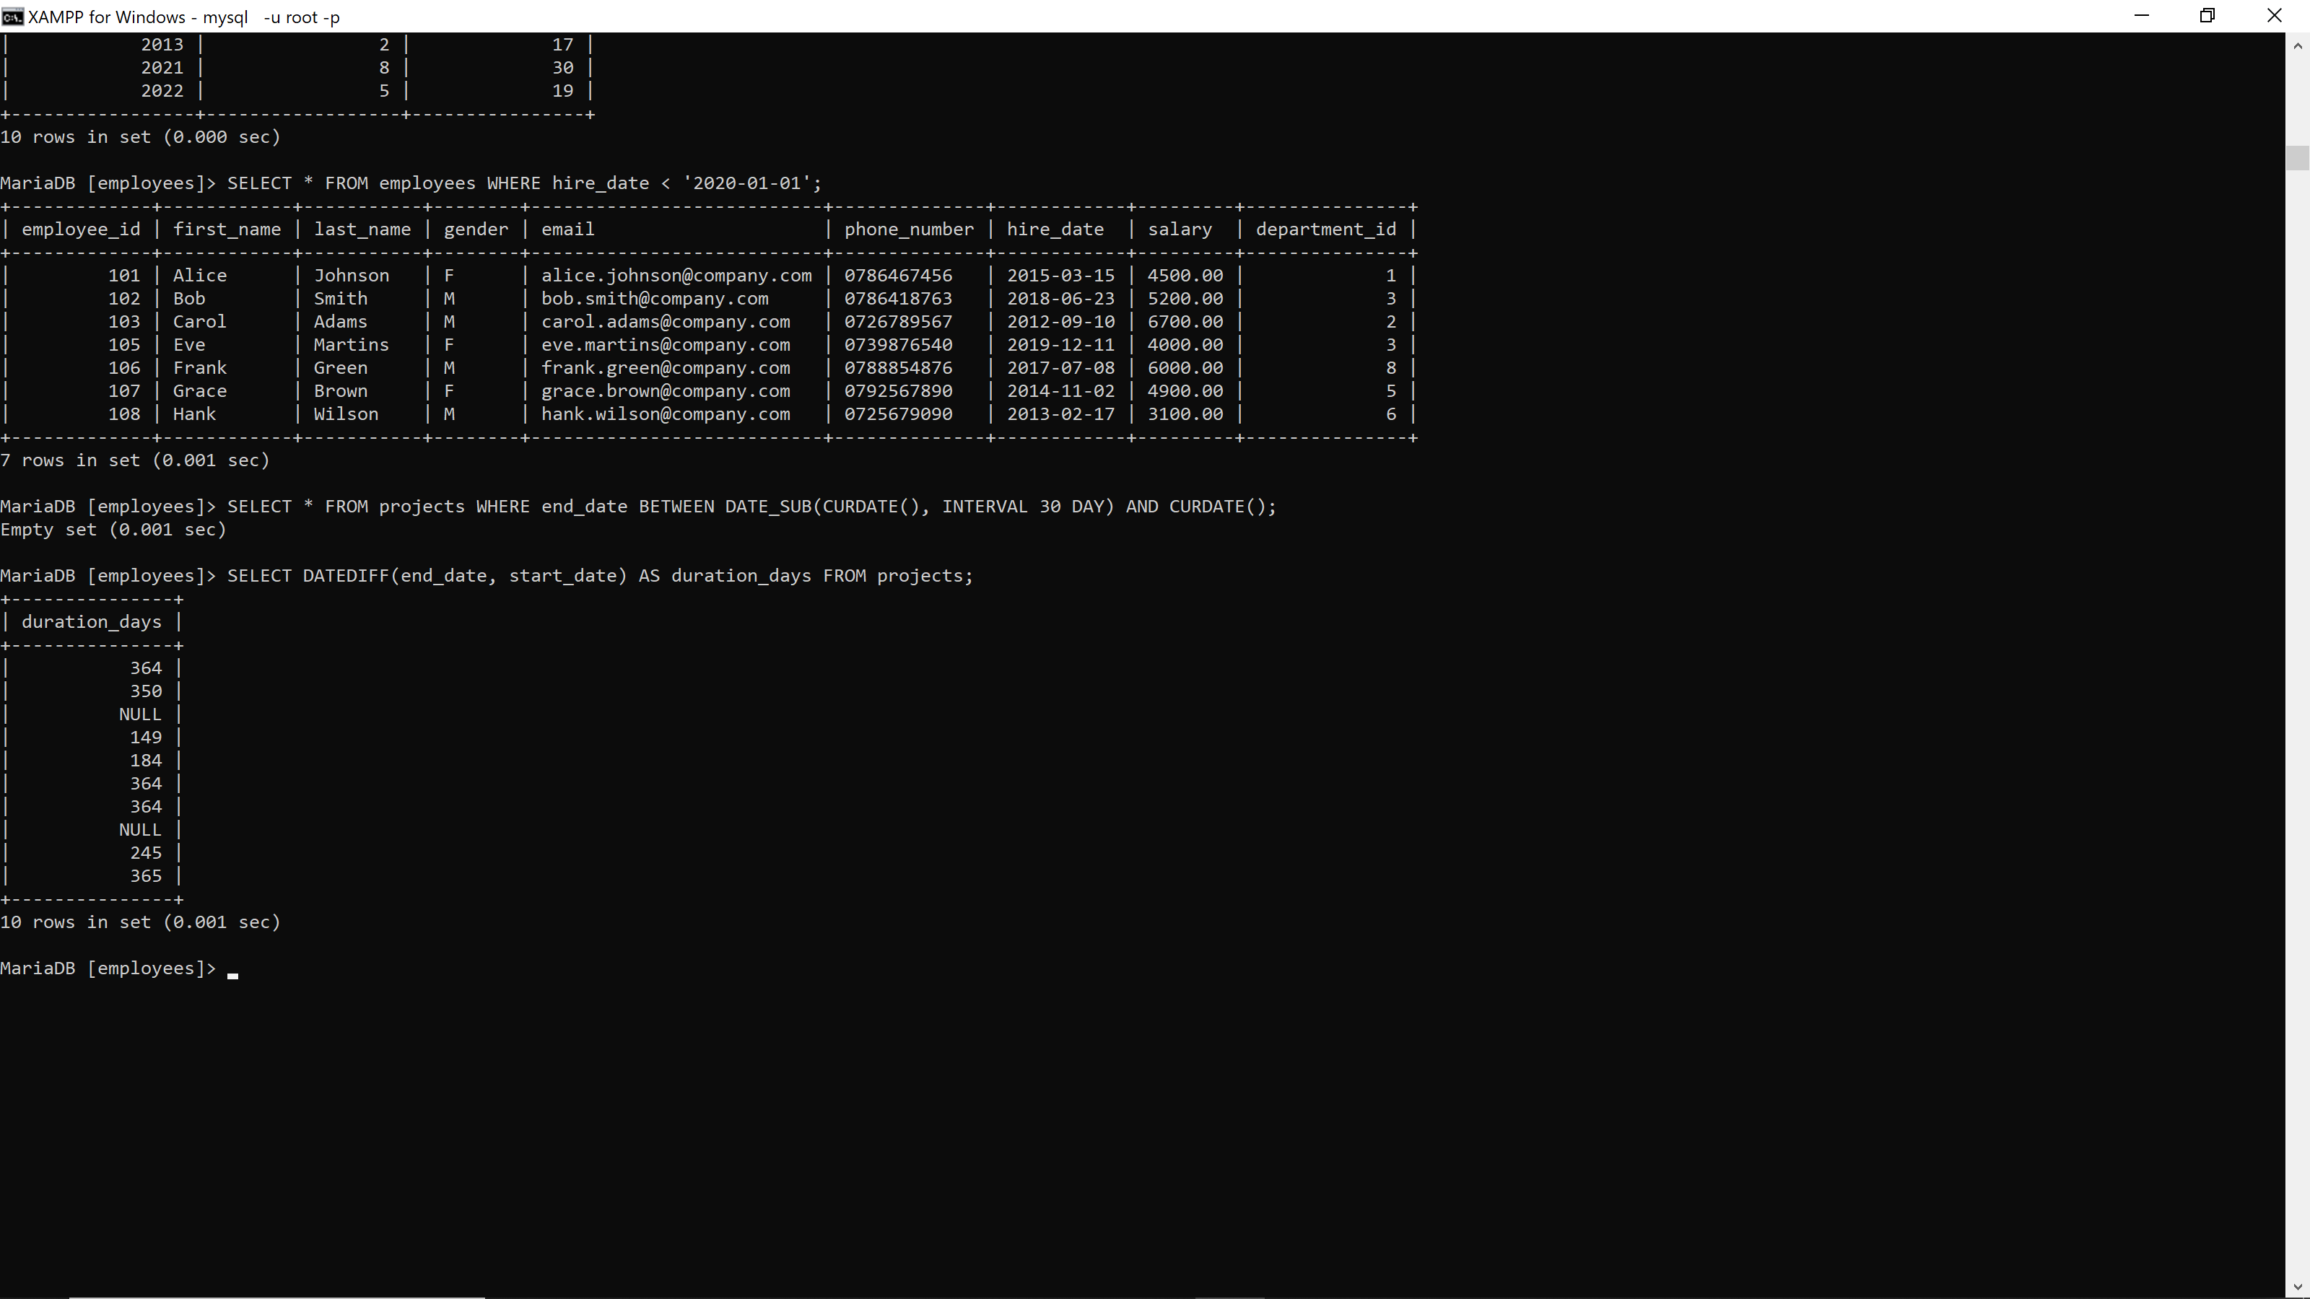

34. SELECT CONCAT(MONTHNAME('2025-07-23'), ' ', DAY('2025-07-23'), ', ', YEAR('2025-07-23')) AS formatted_date; **29376**

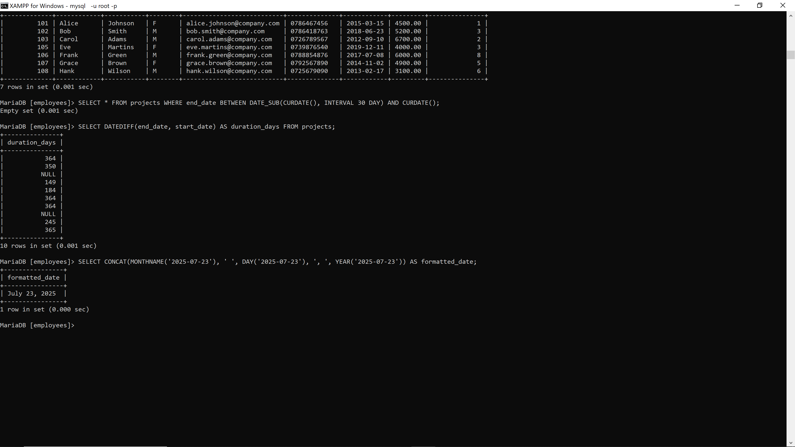

35. SELECT project_name, CASE WHEN end_date IS NULL THEN 'Ongoing' ELSE 'Completed' END AS status FROM projects; **29376**

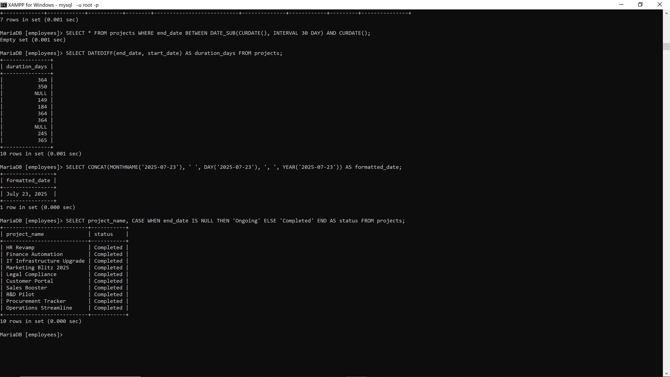

**PART4:Conditional Function**

36. SELECT salary, CASE WHEN salary >= 5000 THEN 'High' WHEN salary >= 3000 THEN 'Medium' ELSE 'Low' END AS salary_label FROM employees; **29376**

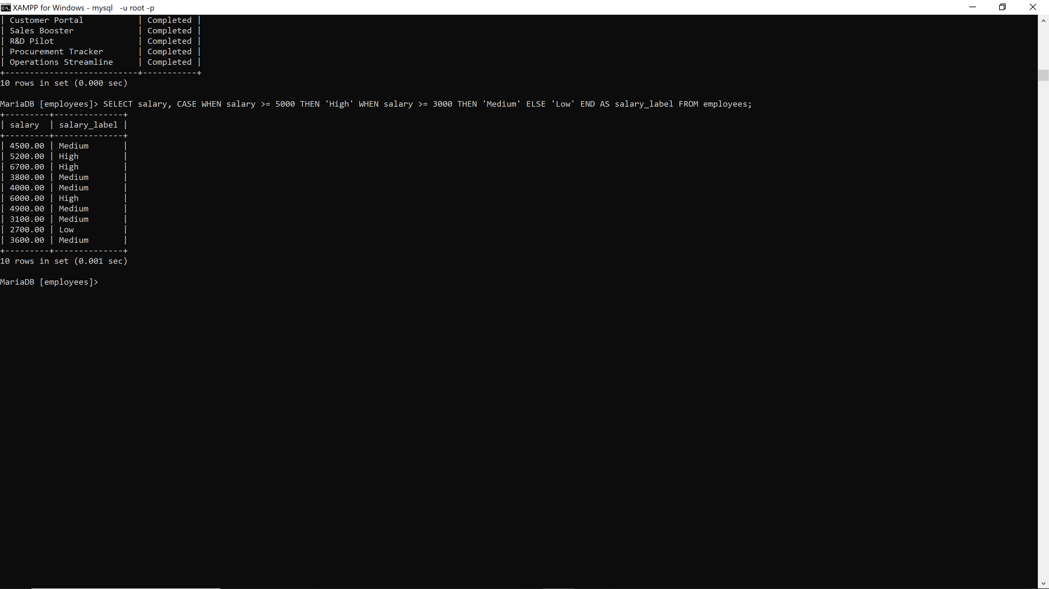

37. SELECT COALESCE(email, 'No Email') FROM employees; **29376**

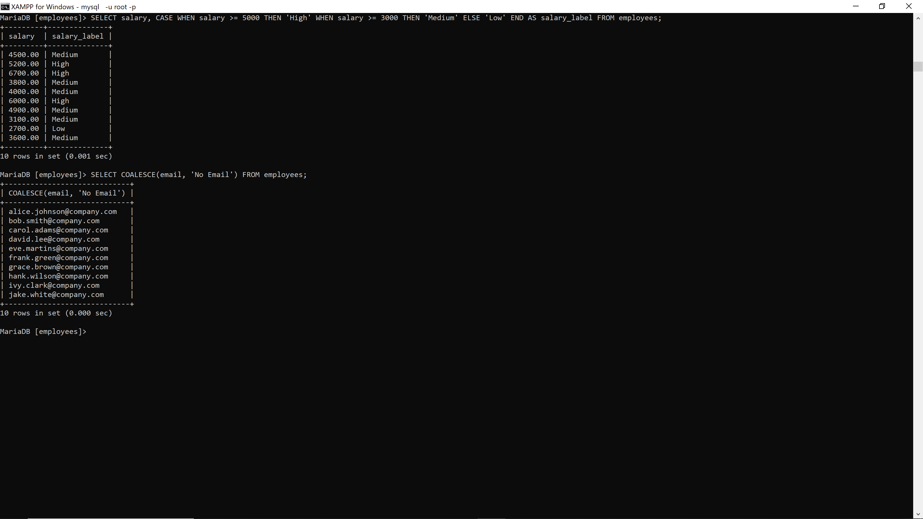

38. SELECT first_name, CASE WHEN hire_date < '2015-01-01' THEN 'Veteran' ELSE 'New' END AS status FROM employees; **29376**

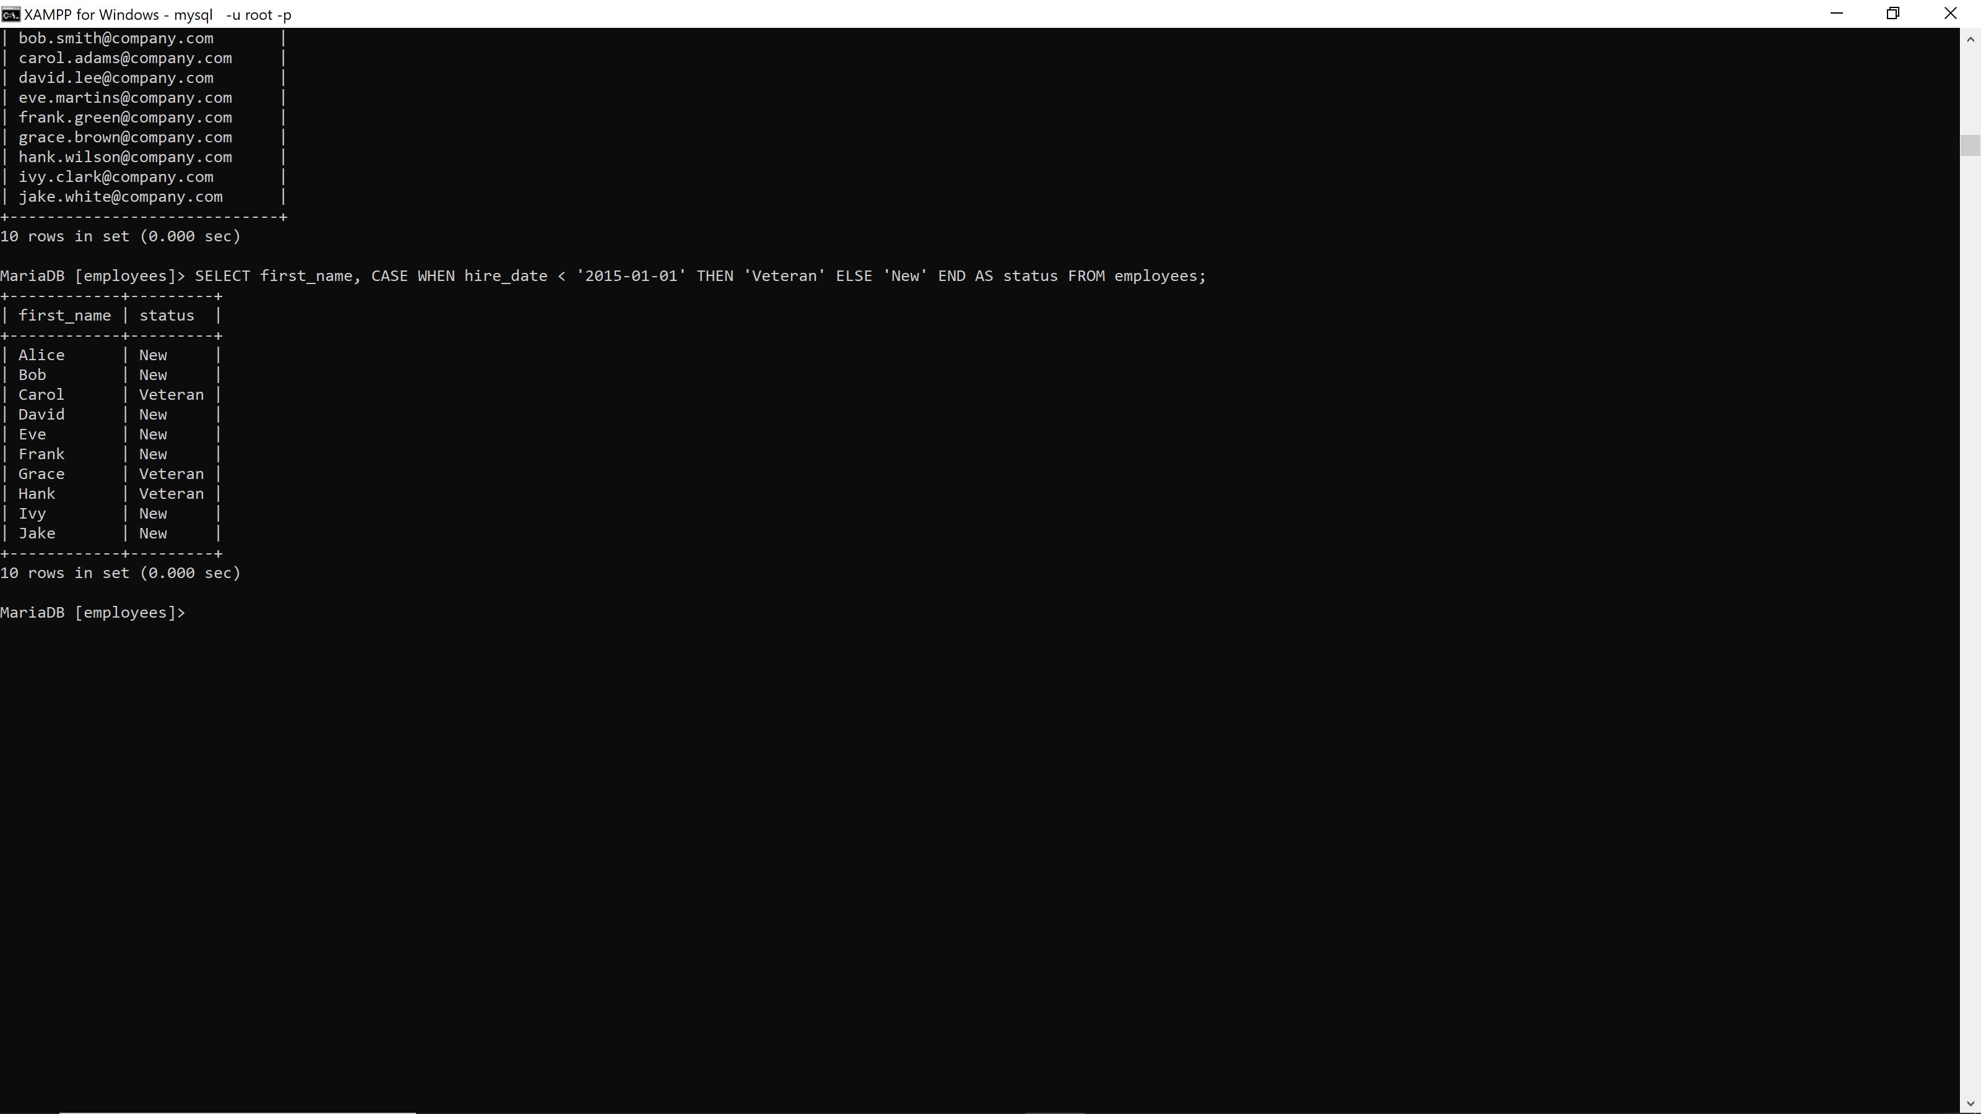

39. SELECT COALESCE(salary, 3000) FROM employees; **29376**

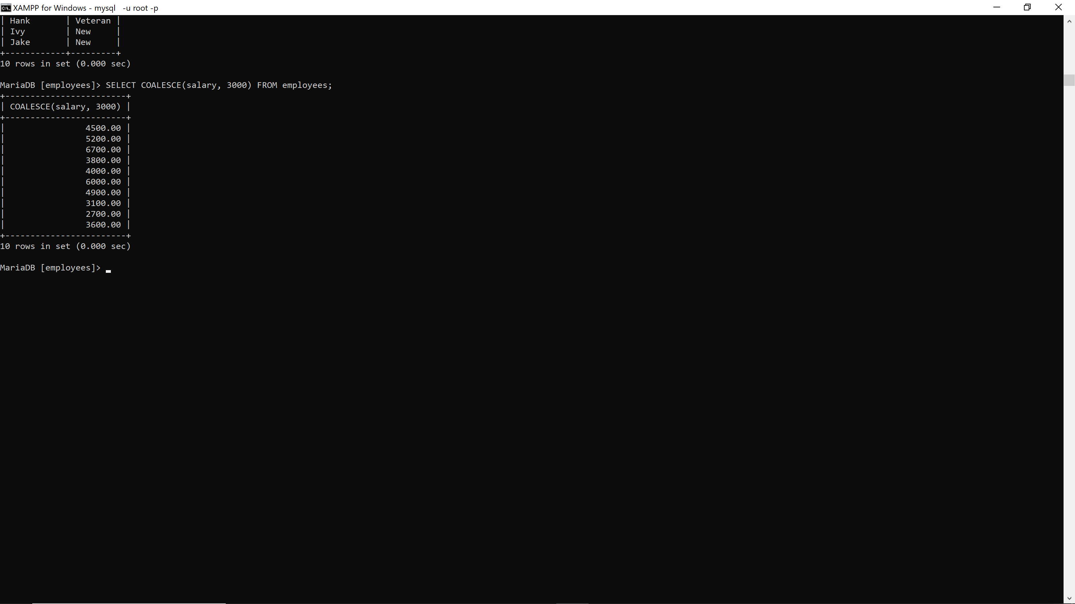

40. SELECT department_name, CASE WHEN department_name = 'Information Technology' THEN 'IT' WHEN department_name = 'Human Resources' THEN 'HR' ELSE 'Other' END AS dept_category FROM departments; **29376**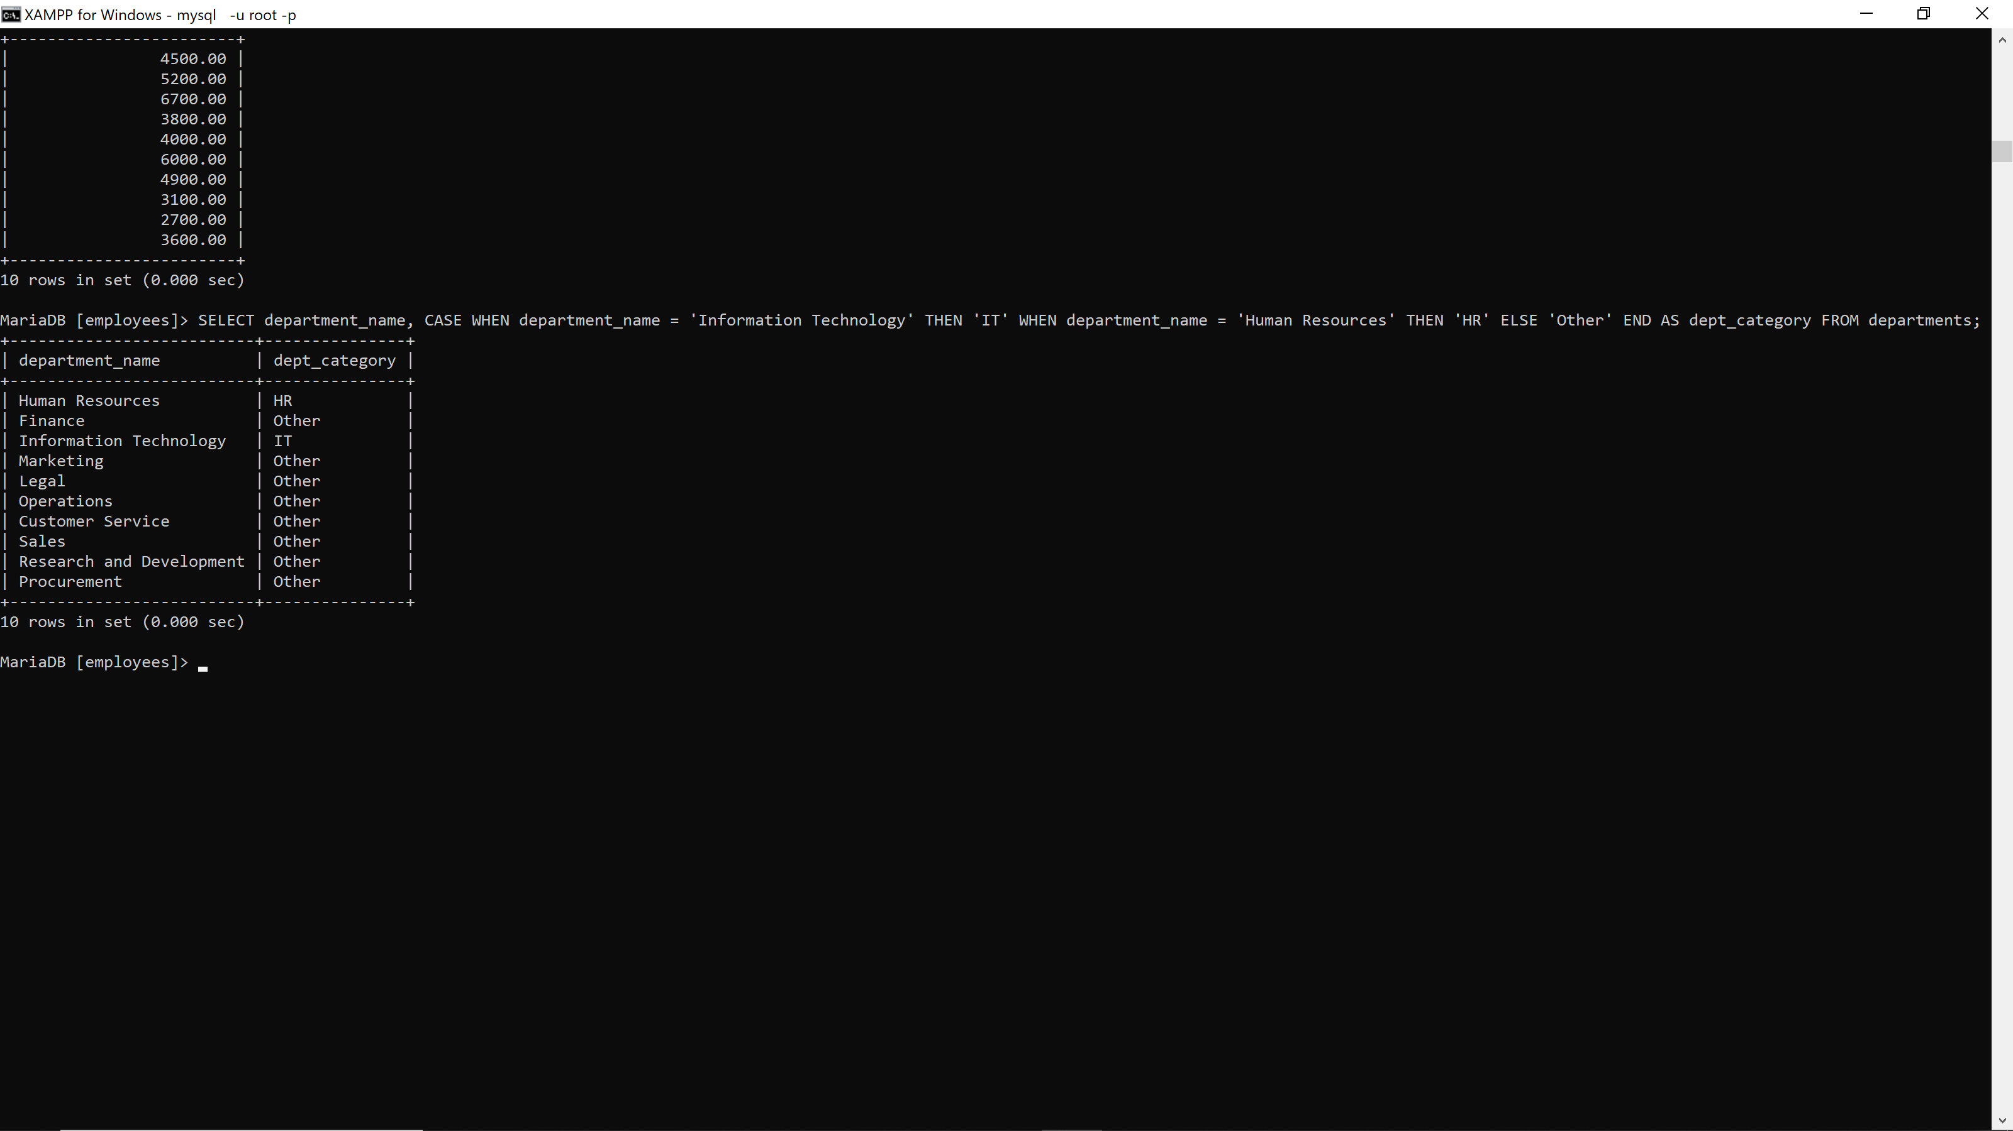

41. SELECT employee_id, CASE WHEN employee_id NOT IN (SELECT employee_id FROM employee_projects) THEN 'Unassigned' ELSE 'Assigned' END AS assignment_status FROM employees; **29376**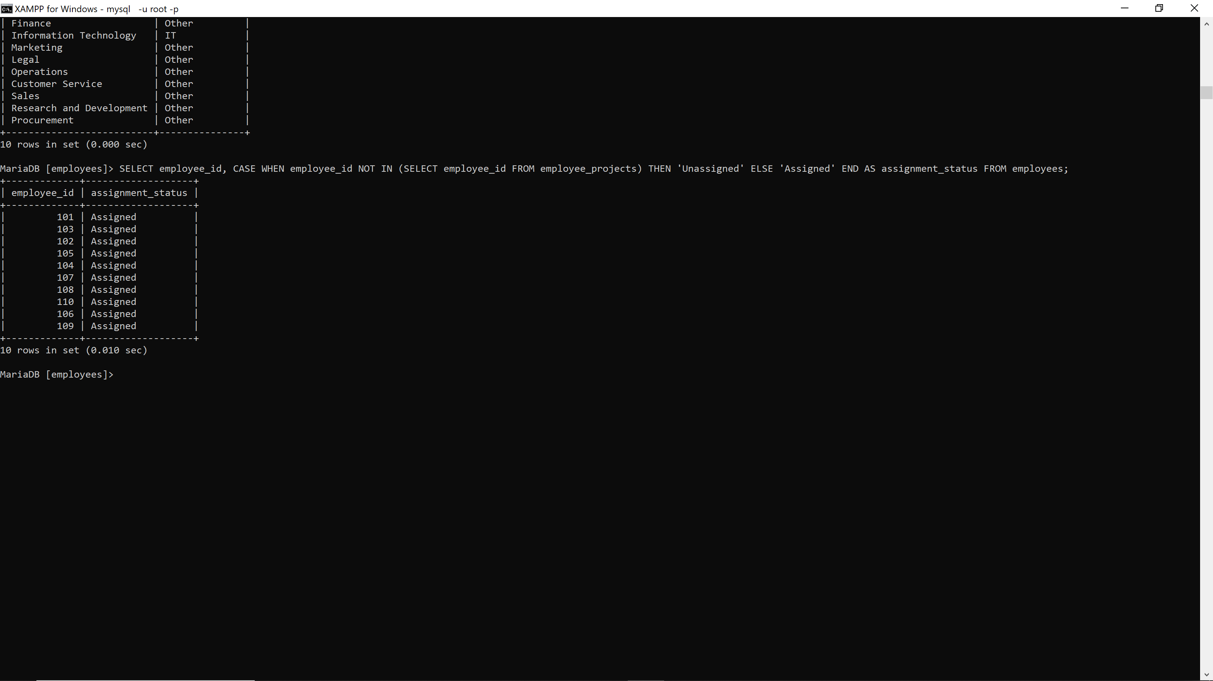

42. SELECT salary, CASE WHEN salary < 3000 THEN 'Low Band' WHEN salary BETWEEN 3000 AND 5000 THEN 'Middle Band' ELSE 'High Band' END AS tax_band FROM employees; **29376** 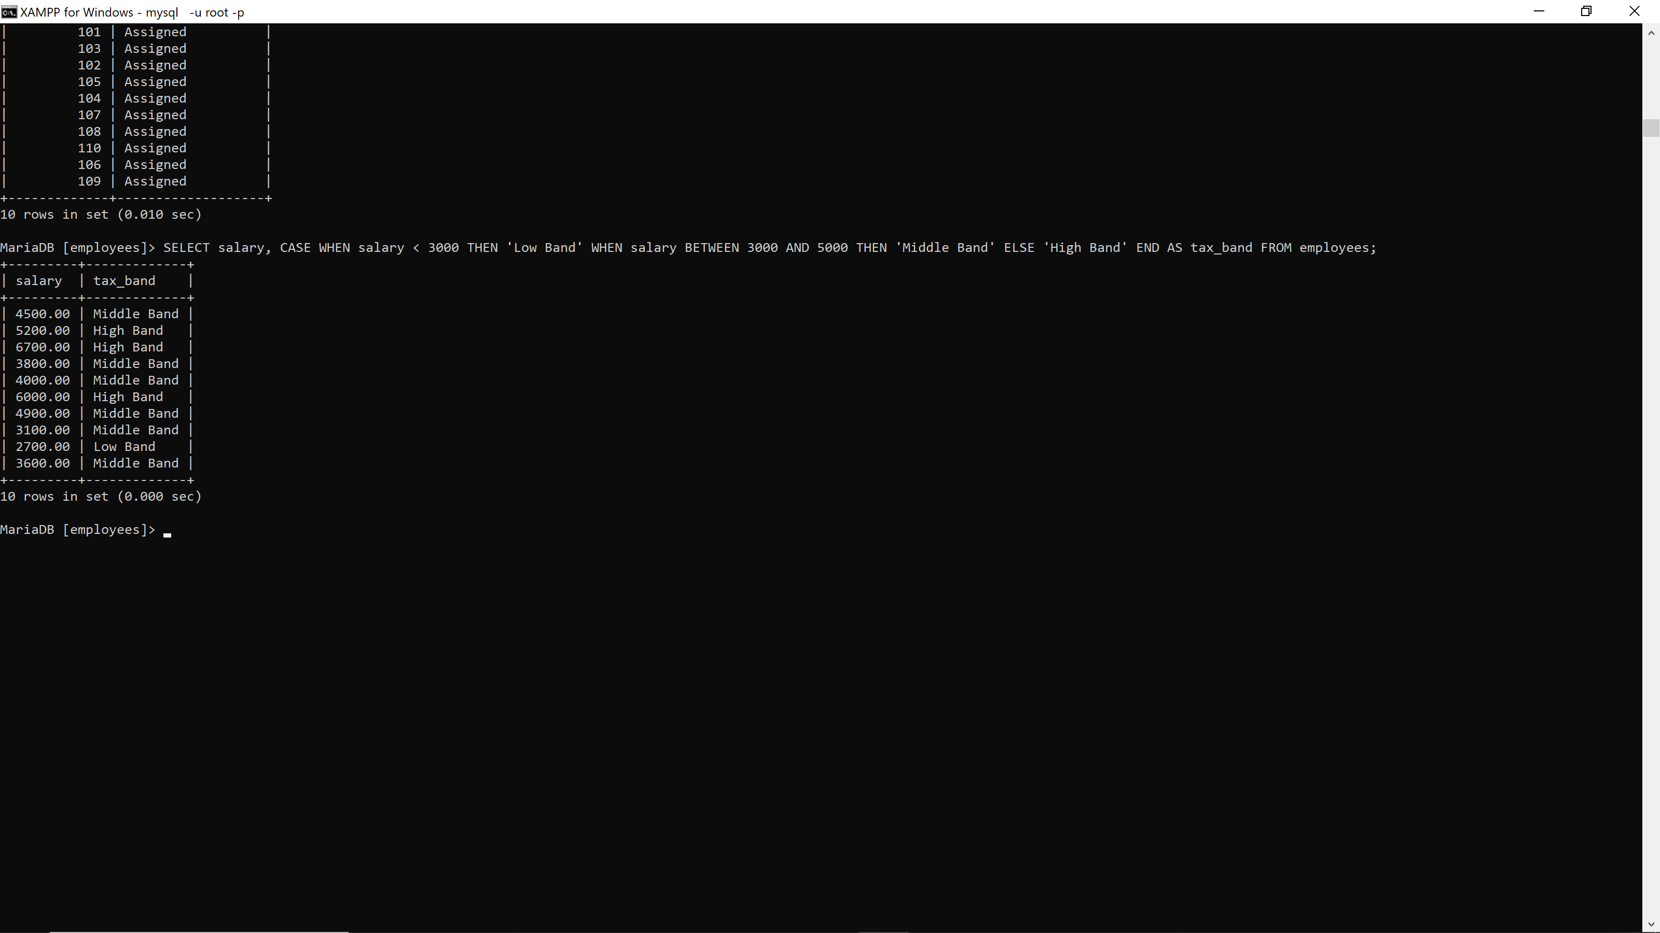

43. SELECT project_name, CASE WHEN DATEDIFF(end_date, start_date) > 365 THEN 'Long' WHEN DATEDIFF(end_date, start_date) > 180 THEN 'Medium' ELSE 'Short' END AS duration_label FROM projects WHERE end_date IS NOT NULL; **29376**

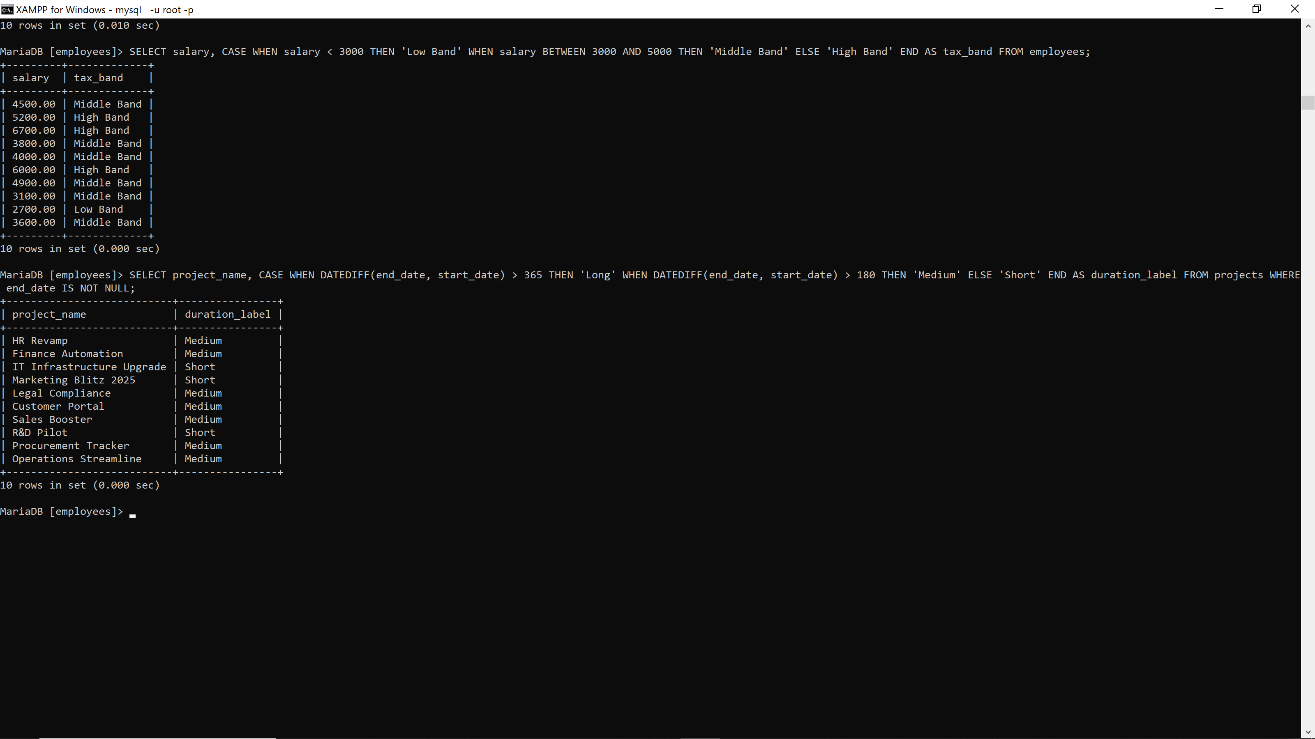

44. SELECT employee_id, CASE WHEN MOD(employee_id, 2) = 0 THEN 'Even' ELSE 'Odd' END AS id_parity FROM employees; **29376**

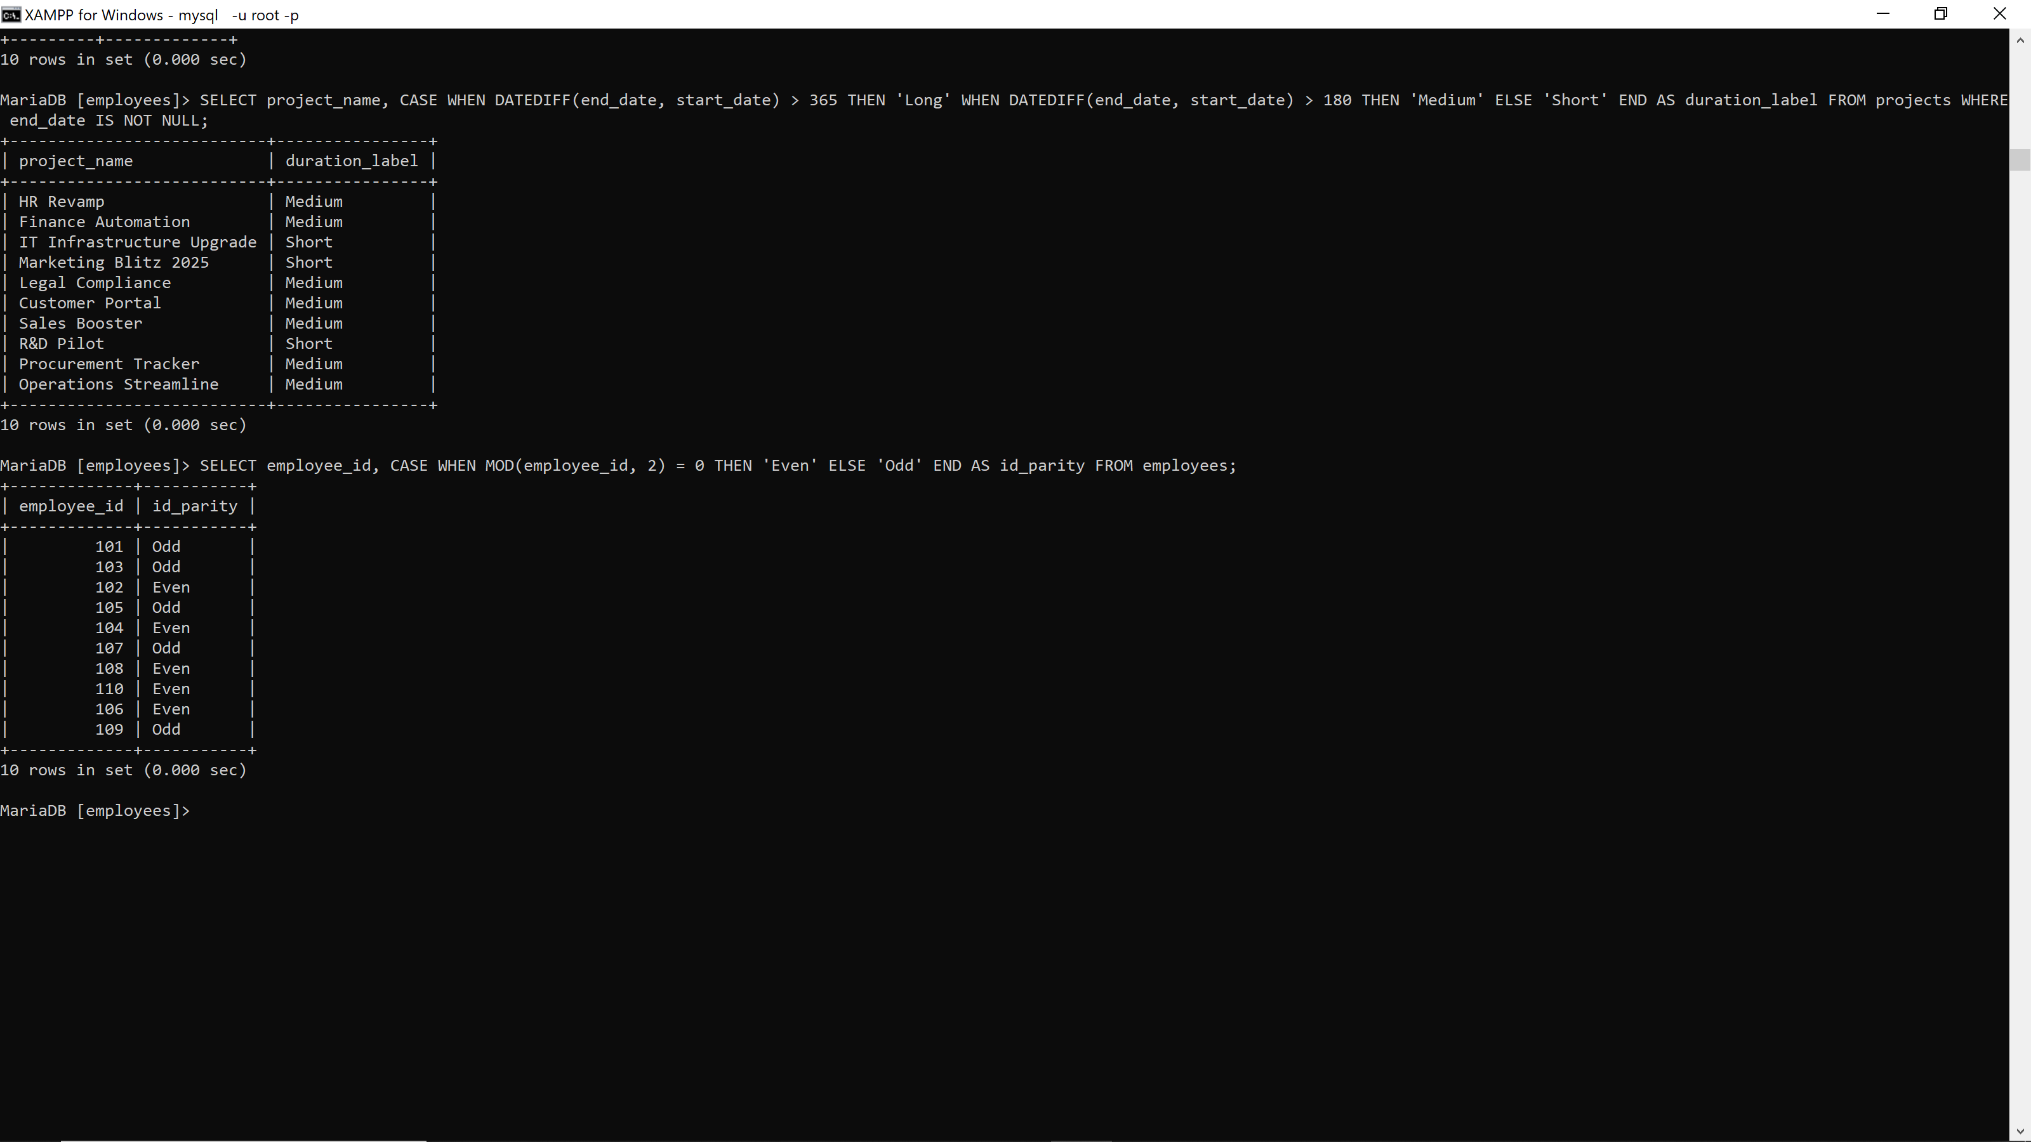

45. SELECT COALESCE(last_name, CONCAT(first_name, ' ', last_name)) AS display_name FROM employees; **29376**

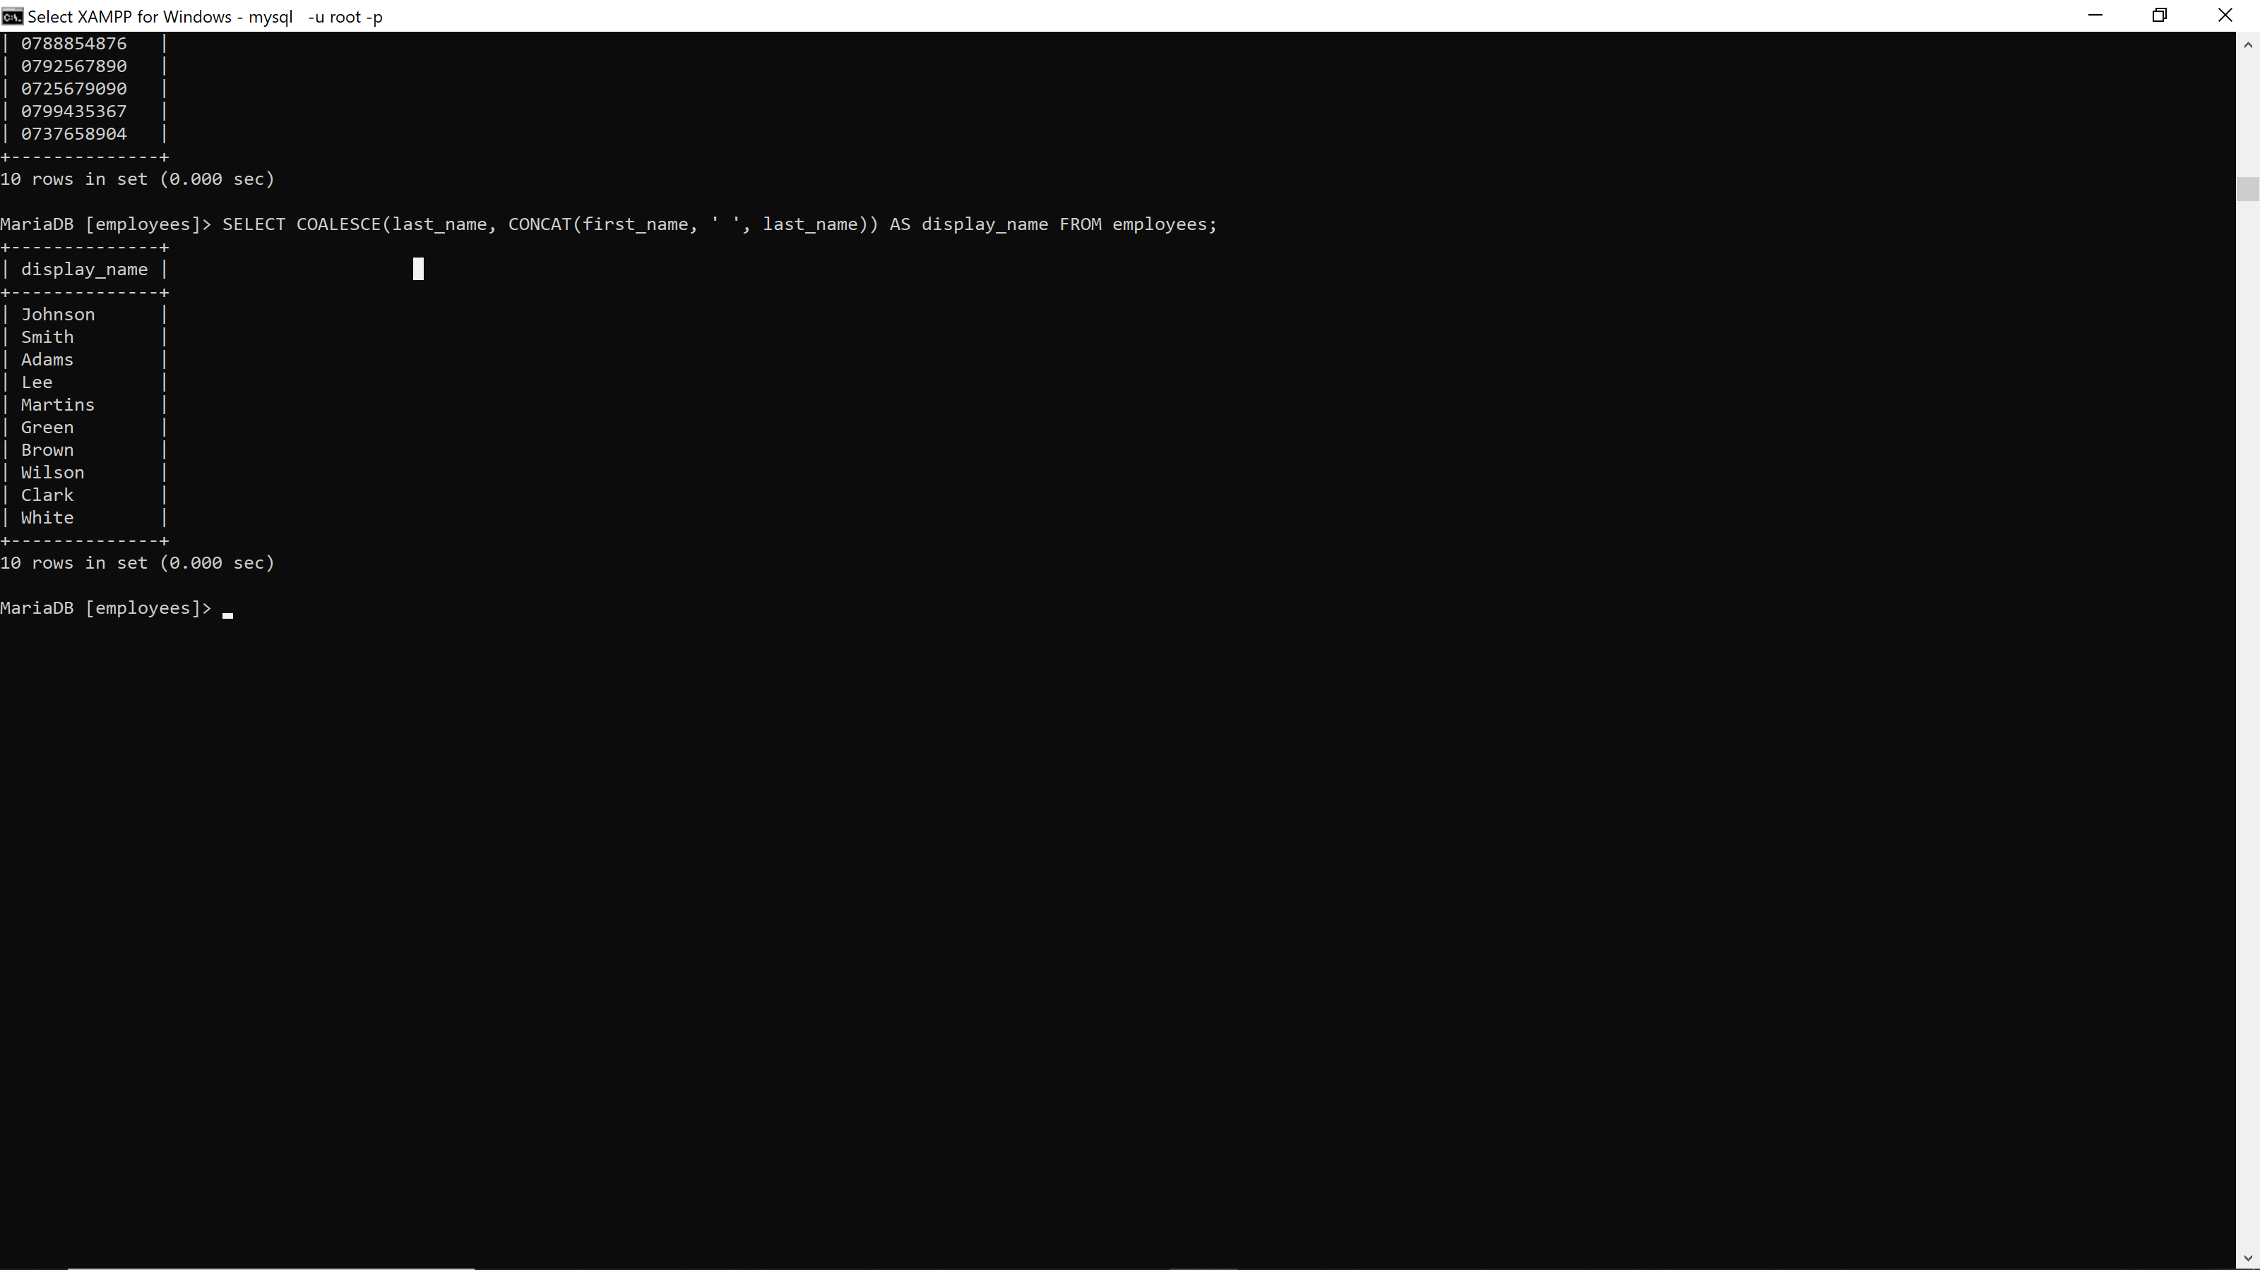

46. SELECT first_name, CASE WHEN LENGTH(first_name) > 10 THEN 'Long Name' ELSE 'Short Name' END AS name_length_label FROM employees; **29376**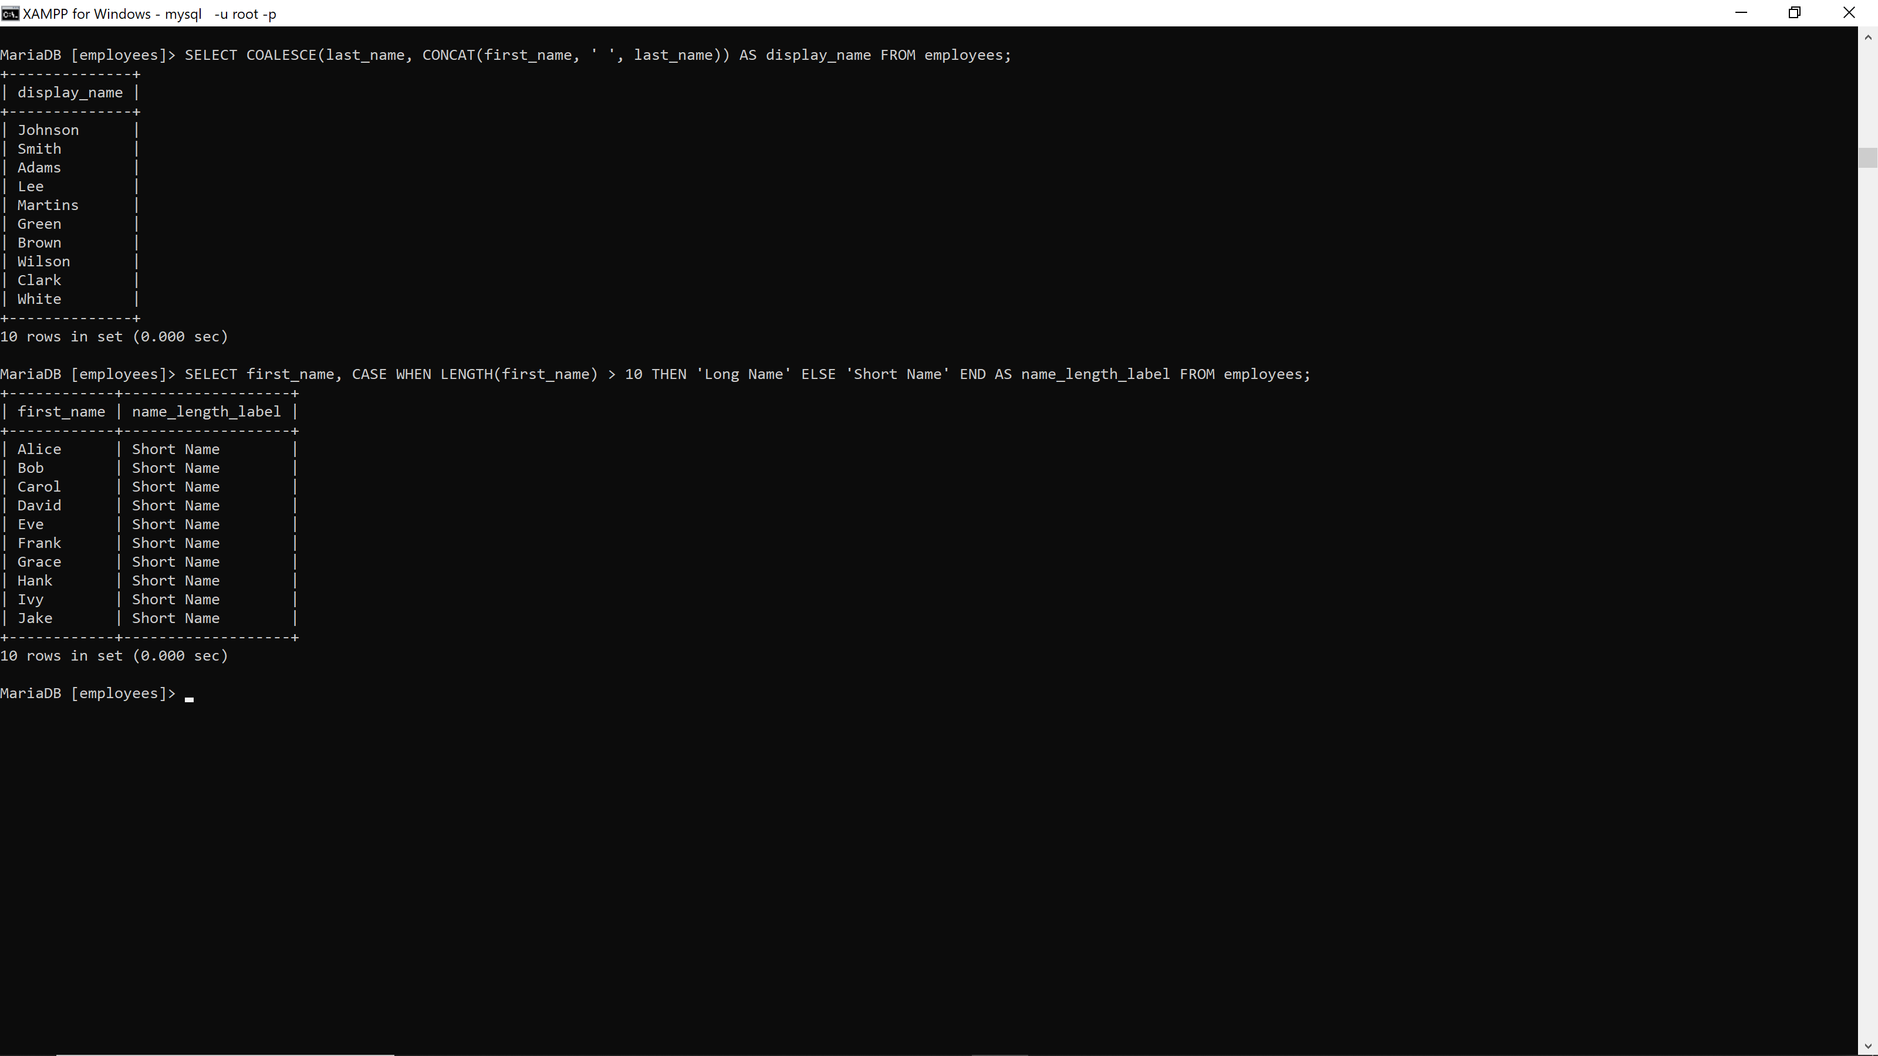

47. SELECT email, CASE WHEN UPPER(email) LIKE '%TEST%' THEN 'Dummy' ELSE 'Real' END AS account_type FROM employees; **29376**

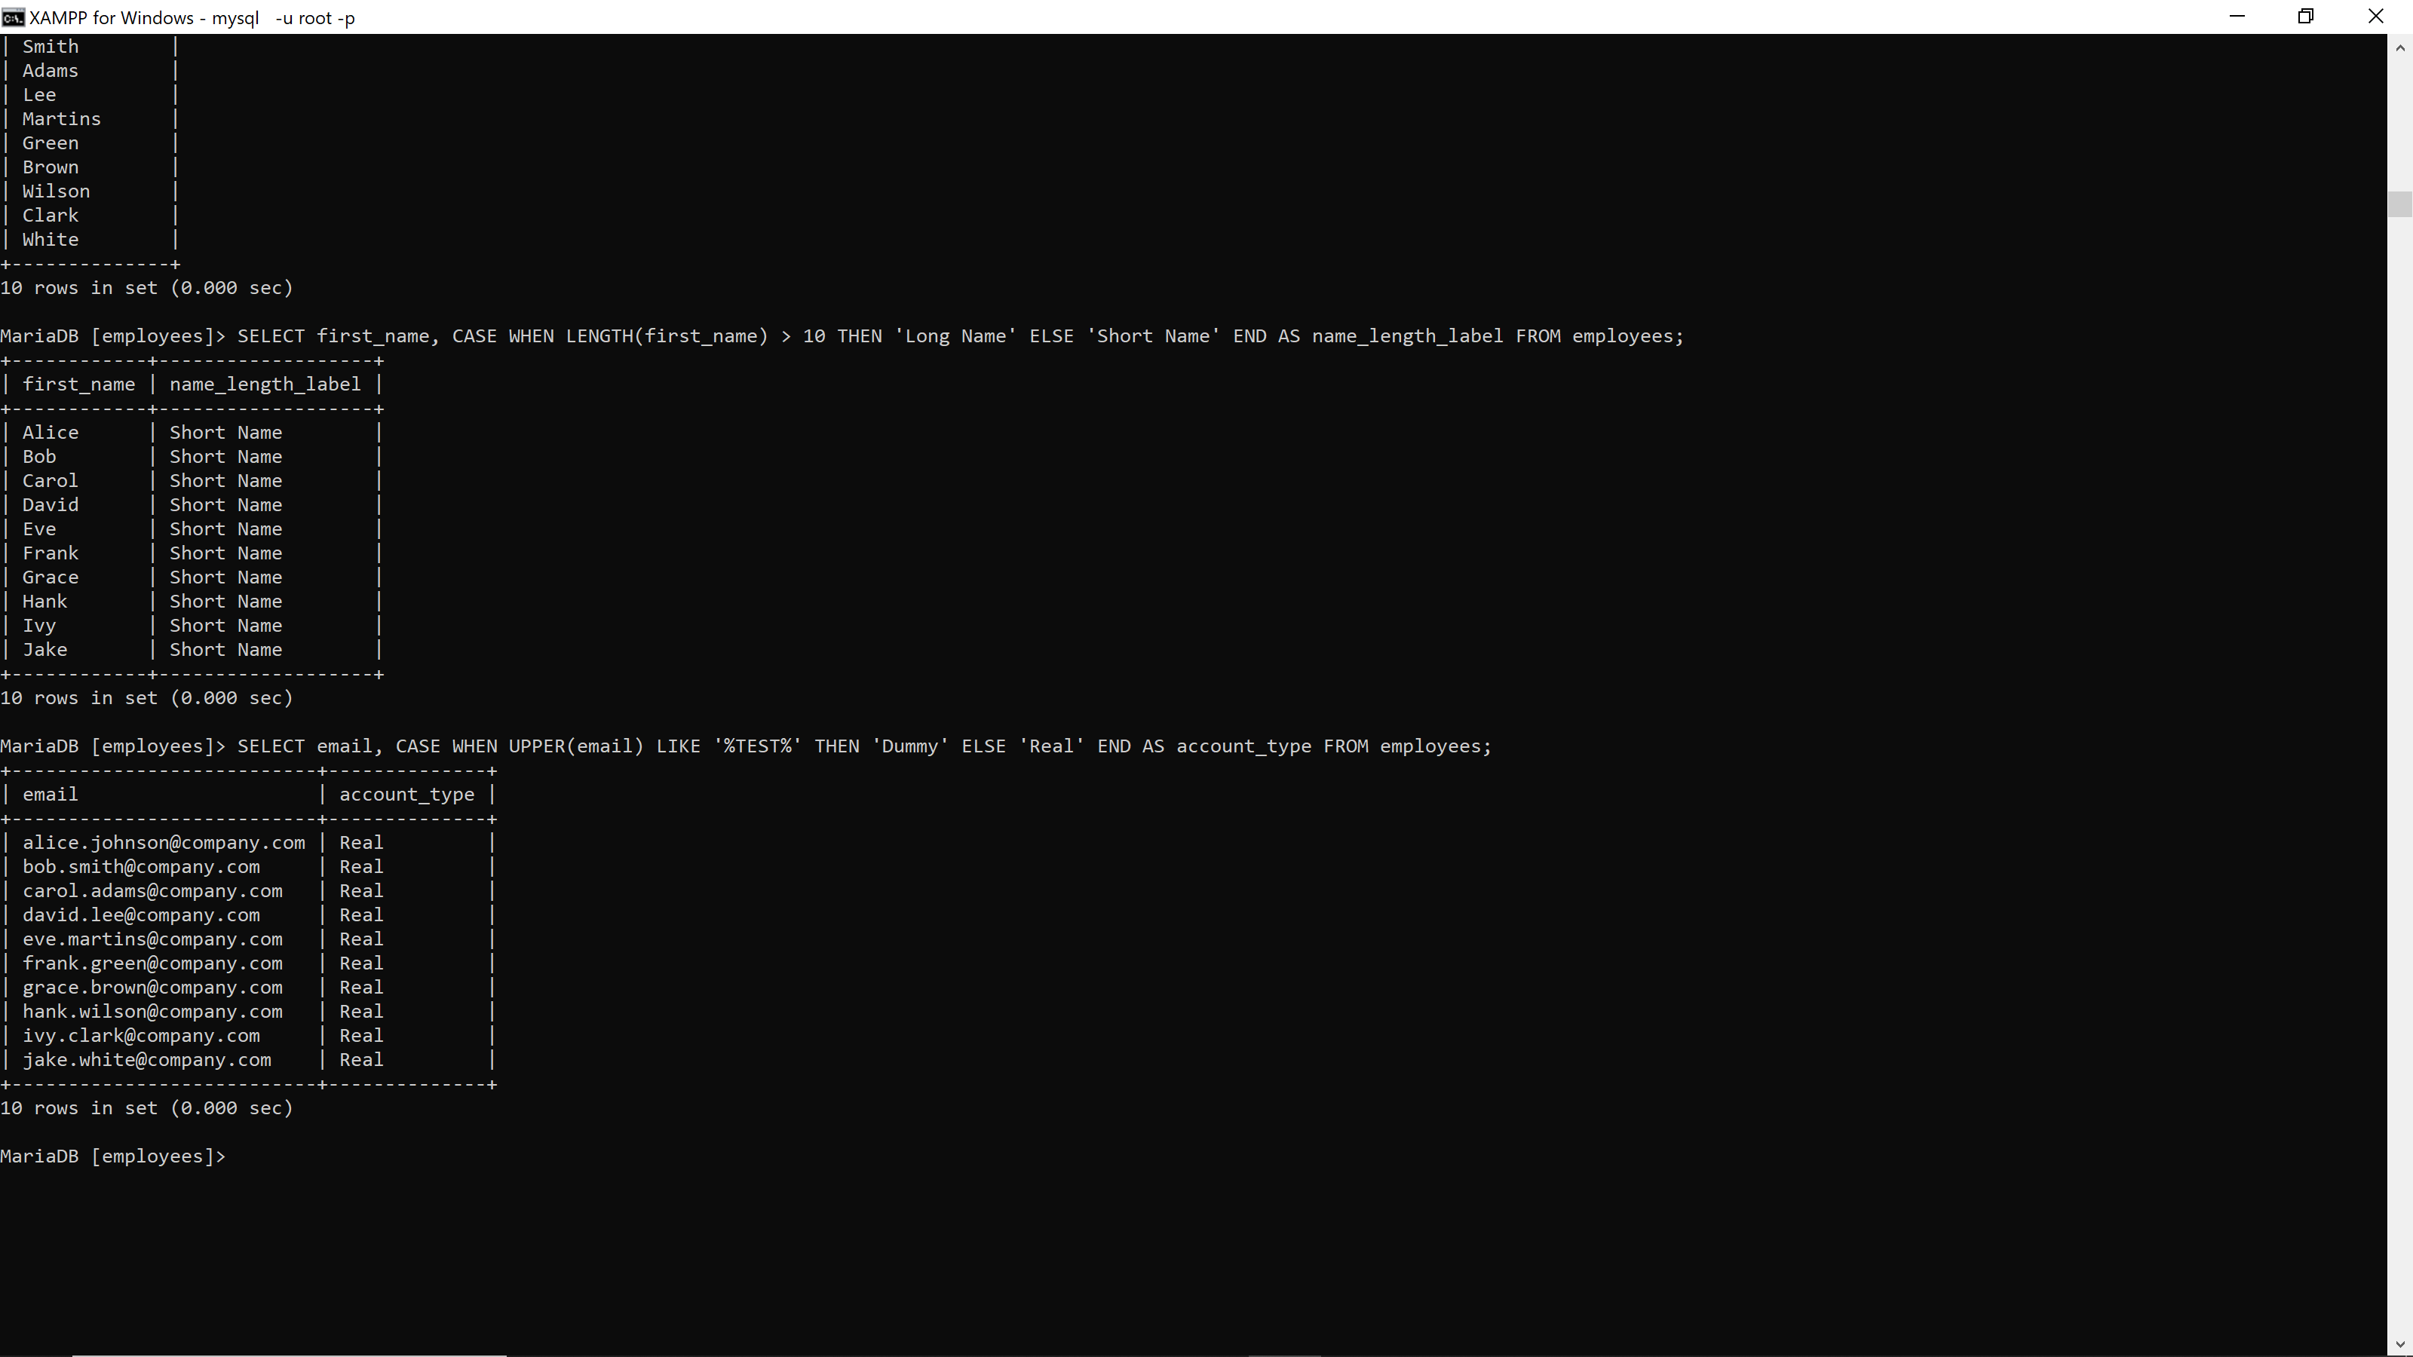

48. SELECT first_name, hire_date, CASE WHEN YEAR(hire_date) < 2015 THEN 'Senior' ELSE 'Junior' END AS seniority FROM employees; **29376**

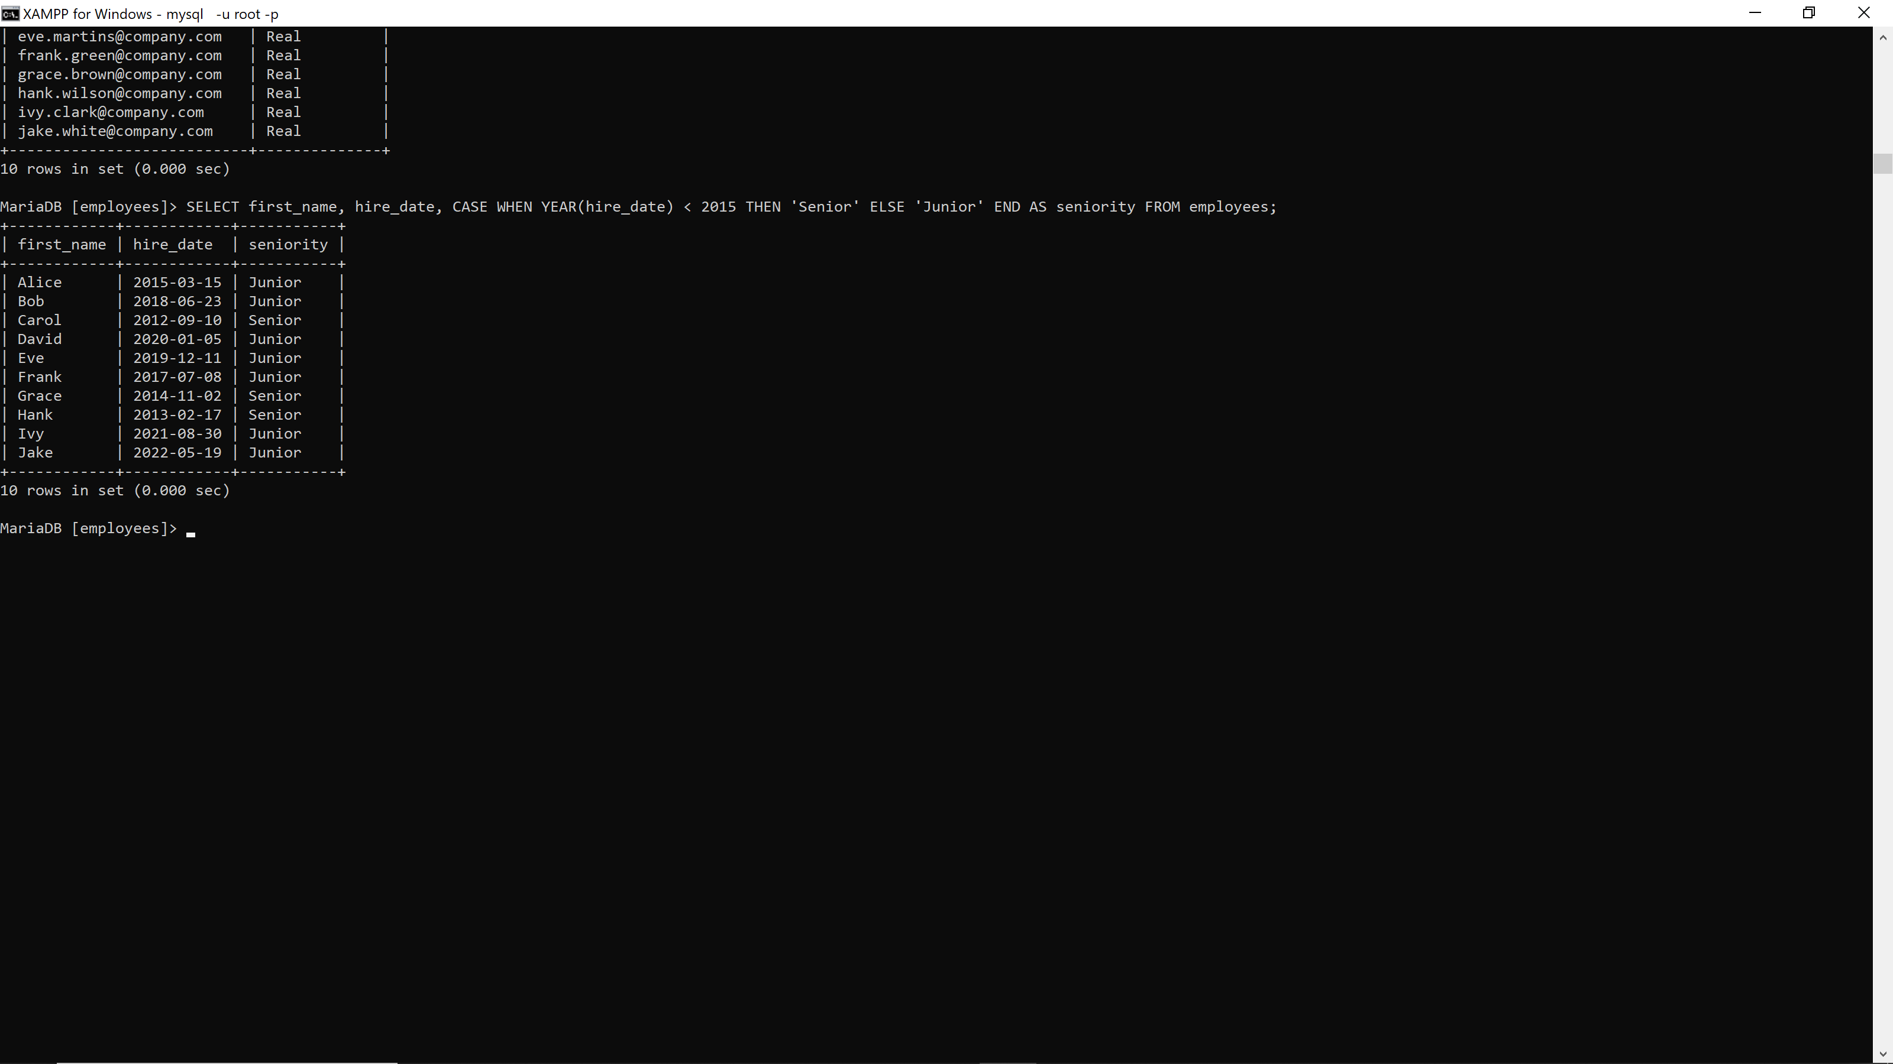

49. SELECT salary, CASE WHEN salary < 3000 THEN '5%' WHEN salary < 5000 THEN '7%' ELSE '10%' END AS increment FROM employees; **29376**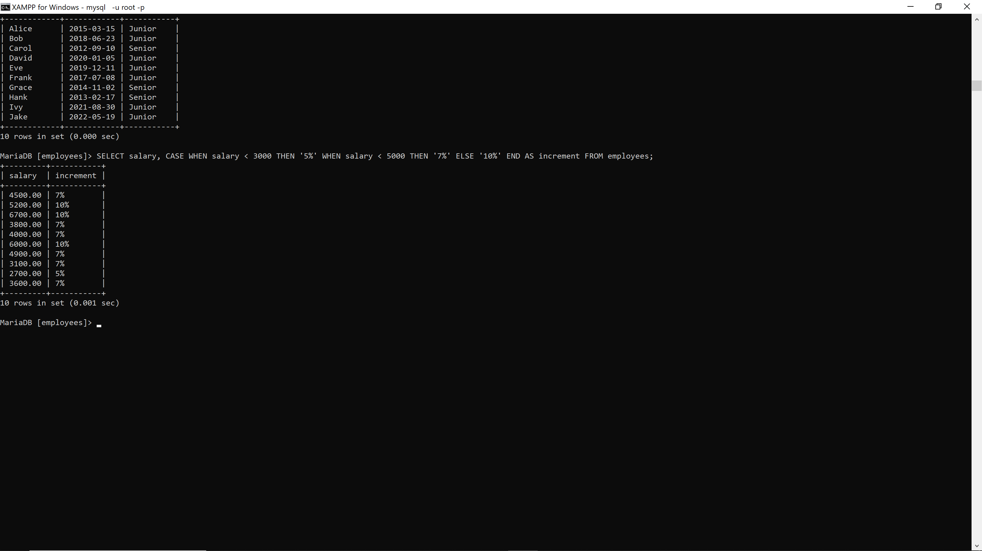

50. SELECT first_name, CASE WHEN MONTH(hire_date) = MONTH(CURDATE()) THEN 'Anniversary Month' ELSE 'Regular Month' END AS hire_anniversary FROM employees; **29376**